

**JMIETI, Radaur**

Lesson Planning of Computer Science Deptt. 4th Semesterw.e.f 1st January’2020

Name of Teacher : Punam Kalra

Designation : A.P.

Subject with code : Discrete Mathematics PC-CS202A

Objective of Course : To familiarize the prospective students with the study & understand the various fundamentals of

1. Set Theory and Logics

2. Relations, Digraphs and Lattices

3. Functions and Combinatorics

4. Algebraic Structures

|  |  |  |  |
| --- | --- | --- | --- |
| **DAY** | **Topic / Chapter Covered** | **Academic Activity** | **Test/Assignment** |
| **Day 1** | Sets and Subsets | **LECTURE** |  |
| **Day 2** | Venn Diagrams | **LECTURE** |  |
| **Day 3** | Operations on Sets, Laws of Set Theory | **LECTURE** |  |
| **Day 4** | Power Sets and Product | **LECTURE** | **Assignment 1** |
| **Day 5** | Partition of Sets, Principle of Inclusion- Exclusion. | **LECTURE** |  |
| **Day 6** | Logic : Propositions and Logical Operations | **LECTURE** |  |
| **Day 7** | Truth Tables | **LECTURE** |  |
| **Day 8** | Equivalence , Implications | **LECTURE** | **Assignment 2** |
| **Day 9** | Laws of Logic, Normal Forms | **LECTURE** |  |
| **Day10** | Predicates and Quantifiers | **LECTURE** |  |
| **Day11** | Predicates and Quantifiers | **LECTURE** |  |
| **Day12** | Mathematical Induction | **LECTURE** |  |
| **Day13** | Product Sets & Partitions | **LECTURE** | **Assignment 3** |
| **Day14** | Relations and Diagraphs | **LECTURE** |  |
| **Day15** | Paths in relations and Diagraphs | **LECTURE** |  |
| **Day16** | Properties of relations | **LECTURE** |  |
| **Day17** | Equivalence and Partially ordered relations | **LECTURE** |  |
| **Day18** | Computer presentation of relation and Digraphs | **LECTURE** | **Assignment 4** |
| **Day19** | Manipulation of relations | **LECTURE** |  |
| **Day20** | Transitive Closure | **LECTURE** |  |
| **Day21** | Wars hall’s Algorithm | **LECTURE** |  |
| **Day22** | Posets and Hasse Diagrams | **LECTURE** |  |
| **Day23** | Lattice | **LECTURE** | **Assignment 5** |
| **Day24** | Definitions & types of Functions:  Injective, Surjective and Bijective | **LECTURE** |  |
| **Day25** | Composition, Identity and Inverse | **LECTURE** |  |
| **Day26** | Permutation and Combination | **LECTURE** |  |
| **Day27** | Pigeon Hole Principle | **LECTURE** | **Assignment 6** |
| **Day28** | Generating Functions | **LECTURE** |  |
| **Day29** | Recurrence- Relations | **LECTURE** | **Assignment 7** |
| **Day30** | Algrebraic Structures with one binary operation | **LECTURE** |  |
| **Day31** | Semi groups, monoids | **LECTURE** |  |
| **Day32** | Groups | **LECTURE** |  |
| **Day33** | Product and Quotient of Algrebraic Structures | **LECTURE** |  |
| **Day34** | ----------------do----------------------- | **LECTURE** |  |
| **Day35** | Isomorphism | **LECTURE** | **Assignment 8** |
| **Day36** | Homomorphism | **LECTURE** |  |
| **Day37** | Automorphism | **LECTURE** |  |
| **Day38** | Cyclic Groups | **LECTURE** |  |
| **Day39** | Normal Sub Group | **LECTURE** |  |
| **Day40** | ------------do------------- | **LECTURE** |  |
| **Day41** | Codes and Group Codes | **LECTURE** |  |
| **Day42** | ------------do------------- | **LECTURE** |  |
| **Day43** | Ring Homomorphism | **LECTURE** | **Assignment 9** |
| **Day44** | Ring Isomorphism | **LECTURE** |  |
| **Day45** | Revision of Unit I | **LECTURE** |  |
| **Day46** | Revision of Unit II | **LECTURE** |  |
| **Day47** | Revision of Unit III | **LECTURE** |  |
| **Day48** | Revision of Unit IV | **LECTURE** |  |
| **Day49** |  |  | **PUT** |

**Outcome of Course**: 1.To develop the tool of algebraic treatment of set operations which leads to Boolean Algebra, in which the operations of intersection, union and difference are interpreted as corresponding to the logical operations, “and”. “or” and “not”, respectively. This is used extensively in the design of digital electronic circuitry, such as that found in calculators and personal computers.

2. Relations and Directed graphs are present in the theory of loop transformations. To study something as basic as the execution ordering of the iterations of a loop nest, we need to know about several ways of partially ordering integer vectors. The most important concept in loop transformations, namely that of dependence, can be viewed as a relation between the members of a certain set.

3.To develop the knowledge of permutations and combinations which are very useful in computer science. It is prerequisite to Graph Theory, Probability etc.

4. To develop the knowledge of semigroups, monoids ,which are used quite intensively in automata theory.

(Sign. of HOD) (Sign. of Teacher Concerned with date)

**Tutorial Sheet 1 (Unit –I)**

**(Set Theory and Logic)**

1.Prove (a) Intersection of sets is distributive w.r.t union of sets. i.e; A $∩\left(B∪C\right)=(A∩B)∪(A∩C)$

(b) Union of sets is distributive w.r.t intersection of sets. i.e;

2. Let A,BandC be sets such that (i) A $⊆B, A ⊆C,$ (B ∩ C) $⊆A$ and A (B ∩ C)

3. Define Sets, their representation with examples.

4. How many bit strings of length 8, either start with L1 or end with 2 bits 00?

5. Determine the power sets of the following sets : (a) {{a}}, (b) { {ɸ}, {{ɸ}}, { ɸ,{ɸ} }, ɸ}.

6. Use Principle of Inclusion – exclusion, to determine the number of permutations of the alphabet (A-Z) that contain at least one of the words DASH, YOUR and TIME.

7. Prove by Mathematical Induction 1.2 + 2.3 + 3.4 +………….+ n(n+1)=

8. Show that ( p is equivalent to (p

9. Define Predicates and Quantifiers with examples

10. Prove the validity of following argument using truth tables. “ If it rains then it will be cold. If it is cold then I shall stay at home. Since it rains therefore, I shall stay at home”.

**Tutorial Sheet 2(Unit –II)**

**Relations, Digraphs and Lattices**

1.. For the three sets , A,B,C, prove that (i) A X (B U C) = (A X B) U (A X C)

(ii) A X (B ∩ C) = (A X B) ∩ (A X C)

2. Define Relations, complement of relation, Classification of Relations and properties. Also discuss presentations of Relations with illustrations.

3. If A={1,2,3,4} , R= { (1,2),(2,3),(3,4),(2.1)}. Find the transitive closure of R.

4. Define Transitive Closure. Explain Warshall’s Algorithm to find Transitive Closure with example.

5. Let A = {4,6,8,10} and R = {(4,4), (4,10), (6,6), (6,8),(8,10)} be a relation defined on a set A. Using Warshall’s Algorithm, find the transitive closure of R.

6. Let R be the relation on set A = {a,b,c,d} defined by R = [ (a,b), (b,c), (d,c), (d,a),(a,d),(d,d)]. Determine

(i) Reflexive Closure of R, (ii) Symmetric Closure of R, (iii) Transitive Closure of R.

7. Define Poset and Lattice with illustrations.

8. Show whether the relation (x,y) ε R, If x ≥ y defined on the set of +ve integers is a partial order relation.

9. Let S be the set of all points in a plane. Let R be a relation such that for any two points a and b ; (a,b) ε R if b is within two centimeter from a. Show that R is an equivalence relation.

10. Consider the set A = {k,l,m,n,p} and the corresponding relation

R = { (k,k),(l,l),(m,m),(n,n),(p,p),(k,m),(k,l),(k,n),(k,p),(m,n),(m,p),(n,p),(l,p)}. Construct the directed graph and the corresponding Hasse diagram of this partial order.

**Tutorial Sheet 3(Unit –III)**

**Functions and Combinatorics**

1. Define Function ,its types with examples.
2. Let f: R→R ; g: R→R be defined by f(x) = x + 1, g(x) = 2 $x^{2}$ +3. Find $f∘g and g∘f.$ Is $f∘g= g∘f?$
3. Investigate the function from {a,b,c,d} to {1,2,3,4,5} with f(a)=4,f(b)=5,f(c)=1,f(d)=3 for one to one.
4. A person writes letters to six friends and addresses the corresponding envelopes. In how ways can the letters be placed in the envelopes so that(i) at least two of them are in wrong envelopes. (ii)all the letters are in wrong envelopes
5. In how many different ways can 5 men and 5 women sit around a table (i) there is no restriction,

(ii) no two women sit together.

1. Solve the recurrence relation: $a_{r}$ + 5 $a_{r-1}$ + 6 $a_{r-2}$ = 3 $r^{2}$
2. Solve the recurrence relation : $a_{r+2}$- 2 $a_{r+1}$ + $a_{r}$ = $2^{r}$ by the method of generating functions with the initial conditions $a_{0}$ = 2 and $a_{1}$ = 1.
3. Define Pigeon Hole Principle. Prove that if n pigeons are assigned to m pigeonholes, then at least one pigeonhole contains two or more pigeons (m<n).
4. Define the following sets recursively:
5. {0,00,10,100,110,0000,1010,…..}
6. {b,bb,bbb,bbbb,………}
7. Consider A=B=C=R and let f: A→B and g: B→C be defined by f(x) = x + 9 and g(y) = $y^{2}$ +3. Find the following composition functions: (i) ($f∘f$)(a), (ii) $g∘g)(a),$

$$\left(iii\right)\left(f∘g\right)\left(b\right),\left(iv\right)\left(gof\right)\left(b\right),\left(v\right)\left(g∘f\right)\left(4\right),(vi) (f∘g)(-4)$$

**Tutorial Sheet 4(Unit –IV)**

**Algebraic Structures**

1. Define Binary Operations, Algebraic Structure, Group, semigroup, Monoid.

2. Show that (Z, +) forms a group.

3. Let G be a group and let a,bε G. Then prove that (i) ()-1 = a, (ii) (a*b)-1 =

4. Consider T as a set of all even integers. Show that the semigroups (Z,+) and (T,+) are isomorphic.

5. Prove that every cyclic group is abelian.

6. For any two subgroups H andK of a group G, the following hold: (i) H $∩K$ is a subgroup of G.

(ii) If H is normal in G, then H $∩K$ is normal in K.

(iii) If H andK both are normal in G, the H $∩K$ is normal in G.

7. Define Codes and Group Codes.

8. Define Ring and Integral Domain. Show that S = {a + √2b: a,bε I} is an integral domain.

9. Let R, the set of real numbers under addition. That is , * and ●.both correspond to addition.Let f:R→R, such that f(x) = kx for any xεR. Show that f is an isomoephism.

10. Consider a ring (R, +, *) defined by a*a =a. Determine whether the ring is commutative or not.



**Lesson Planning for semester Started w.e.f. 13.01.20 (4th Sem)**

**Subject: Internet Fundamentals (PC-CS204A)**

**Name of teacher with designation: Priyanka Kamboj (AP)**

**Department: CSE**

**Objective of Course :**

1. Describe the important features of the Web and Web browser software

2. Evaluate e-mail software and Web-based e-mail services

3. Use search engines and directories effectively

4. Find, evaluate, and use online information resources

5. Use FTP and other services to transfer and store data

6. Demonstrate the use of real-time chat and briefly describe the history of the wireless Internet

7. Use mailing lists, newsgroups, and newsfeeds 8. Create HTML documents and enhance them with browser extensions

|  |  |  |  |  |
| --- | --- | --- | --- | --- |
| **Month** | **Class** | **Topic/Chapter Covered** | **Academic Activity** | **Test/ Assignment** |
| **January 18**  L1 | B.Tech 4th sem | Introduction to networks and internet, | Lecture |  |
| L2 | B.Tech 4th sem | history, Internet, Intranet & Extranet | Lecture |  |
| L3 | B.Tech 4th sem | Working of Internet, Internet Congestion, internet culture, business culture on internet | Lecture |  |
| L4 | B.Tech 4th sem | Collaborative computing & the internet | Lecture |  |
| L5 | B.Tech 4th sem | Modes of Connecting to Internet | Lecture |  |
| L6 | B.Tech 4th sem | Internet Service Providers, Internet address | Lecture |  |
| L7 | B.Tech 4th sem | standard address | Lecture |  |
| L8 | B.Tech 4th sem | domain name, DNS | Lecture |  |
| L9 | B.Tech 4th sem | IP.v6.Modems | Lecture | Assignment from 1st Unit |
| L10 | B.Tech 4th sem | Speed and time continuum | Lecture |  |
| L11 | B.Tech 4th sem | communications software, internet tools | Lecture |  |
| L12 | B.Tech 4th sem | Introduction, Miscellaneous Web Browser details | Lecture |  |
| L13 | B.Tech 4th sem | Miscellaneous Web Browser details | Lecture |  |
| L 14 | B.Tech 4th sem | searching the www, Directories search engines | Lecture |  |
| **February 18**  L 15 | B.Tech 4th sem | meta search engines, search fundamentals | Lecture |  |
| L 16 | B.Tech 4th sem | search strategies, working of the search engines | Lecture |  |
| L 17 | B.Tech 4th sem | Telnet and FTP | Lecture | Assignment from 2nd Unit |
| L 18 | B.Tech 4th sem | HTTP, Gophar Commands | Lecture |  |
| L 19 | B.Tech 4th sem | TCP/IP. | Lecture |  |
| L20 | B.Tech 4th sem | Introduction to Browser, Coast-to-coast surfing | Lecture |  |
| L 21 | B.Tech 4th sem | hypertext markup language | Lecture |  |
| L 22 | B.Tech 4th sem | Web page installation, Web page setup, Basics of HTML | Lecture |  |
| L23 | B.Tech 4th sem | formatting and hyperlink creation, Using FrontPage Express, Plug-ins. | Lecture |  |
| L 24 | B.Tech 4th sem | internet plateform and mailing systems  Introduction, advantages and disadvantages, | Lecture |  |
| L 25 | B.Tech 4th sem | User Ids, Pass words, e-mail addresses, message components, message composition | Lecture |  |
| L26 | B.Tech 4th sem | mailer features, E-mail inner workings, E-mail management | Lecture |  |
| **March 18**  L 27 | B.Tech 4th sem | MIME types | Lecture |  |
| L 28 | B.Tech 4th sem | Newsgroups, mailing lists | Lecture | Assignment from 3rd Unit |
| L29 | B.Tech 4th sem | chat rooms, secure-mails , SMTP | Lecture |  |
| L30 | B.Tech 4th sem | PICO | Lecture |  |
| L 31 | B.Tech 4th sem | PINE, Library cards catalog, online ref. works. | Lecture |  |
| L 32 | B.Tech 4th sem | Basic and advanced HTML | Lecture |  |
| L33 | B.Tech 4th sem | Basics of scripting languages – XML, DHTML | Lecture |  |
| L34 | B.Tech 4th sem | Java scripts basics | Lecture |  |
| L35 | B.Tech 4th sem | Introduction to Web Servers: PWS | Lecture |  |
| L 36 | B.Tech 4th sem | IIS, Apache | Lecture |  |
| L 37 | B.Tech 4th sem | Microsoft Personal Web Server. Accessing & using these servers. | Lecture |  |
| L 38 | B.Tech 4th sem | Privacy and security Introduction | Lecture |  |
| **April 18**  L 39 | B.Tech 4th sem | Software Complexity, Attacks | Lecture |  |
| L40 | B.Tech 4th sem | security and privacy levels, security policy | Lecture |  |
| L 41 | B.Tech 4th sem | accessibility and risk analysis | Lecture | Assignment from 4th Unit |
| L 42 | B.Tech 4th sem | Encryption schemes, Secure Web document | Lecture |  |
| L43 | B.Tech 4th sem | Digital Signatures | Lecture |  |
| L44 | B.Tech 4th sem | Firewalls, Intrusion detection systems | Lecture |  |

**Outcome of Course:** Students will be able to

1. Describe how the **Internet** works

2. How to use email, newsletter and mailing list

3. How to design webpage using html and java script

**TUTORIAL SHEET-1**

Q1. What are the ways of accessing mail. Q2. Explain the concept of email addressing. Q3. Define the following:

1. SMTP
2. PICO

Q4. Write short note on library cards, catalog and on line ref. works. Q5. Explain MIME?

**TUTORIAL SHEET-2**

Q1. Difference between internet, intranet and extranet. Q2. What do you mean by ISPs?

Q3. Explain different modes of connecting to internet.

Q4. Write short note on DNS. Q5. Describe internet tools.

Q1. How search engine works. Q2. Explain FTP,HTTP,TCP/IP?

**TUTORIAL SHEET-3**

Q3. How web pages setup are installed. Q4. How hyperlinks are created in HTML. Q5. Write short note on web browsers.

**TUTORIAL SHEET-4**

Q1. Is HTML a programming language. IF no, explain? Q2. What is the relation between HTML,DHTML,XML. Q3. How forms are created using HTML?

Q4. Describe cascading style sheets.

Q5. Explain how to determine the machine names of remote web server.

**TUTORIAL SHEET-5**

Q1. Explain encryption schemes?

Q2. What are internal and external attacks?

Q3. What do you mean by Intrusion detection system? Q4. Explain Firewalls in detail.

Q5. Explain various levels of security and privacy.



**JMIETI, Radaur**

Lesson Planning of Operating Systems Deptt. .CSE Semester 4th

Name of Teacher : Ms.Upasana Sood

Designation : Assistant Professor & Head

Subject with code : Operating Systems (PC-CS-206A)

Objectives of Course :

1. To learn the fundamentals of Operating Systems.

2. To learn the mechanisms of OS to handle processes and threads and their communication

3. To learn the mechanisms involved in memory management in contemporary OS

4. To know the components and management aspects of concurrency management

|  |  |  |  |
| --- | --- | --- | --- |
| Month | Topic /chapter  covered | Academic activity | Test / assignment |
| **JAN** | Introduction to OS. Operating system functions, Different types of O.S.: batch process, multiprogrammed, time-sharing, real-time, distributed, parallel. | **Teaching** |  |
| **JAN** | System Structure: Computer system operation | **Teaching** |  |
| **JAN** | I/O structure, storage structure, storage hierarchy | **Teaching** |  |
| **JAN** | Different types of protections, operating system structure (simple, layered, virtual machine) | **Teaching** |  |
| **JAN** | O/S services, system calls. | **Teaching** |  |
| **JAN** |  |  | Test |
| **FEB** | CPU Scheduling: Scheduling criteria, preemptive & non-preemptive scheduling | **Teaching** |  |
| **FEB** | Scheduling algorithms, algorithm evaluation, multi-processor scheduling | **Teaching** |  |
| **FEB** | Threads: overview, benefits of threads, user and kernel threads | **Teaching** |  |
| **FEB** | Process Management: Concept of processes, process states, process control | **Teaching** |  |
| **FEB** | Co-operating processes, interprocess communication. | **Teaching** |  |
| **FEB** | Process Synchronization: background, critical section problem, critical region | **Teaching** |  |
| **FEB** | Synchronization hardware, Classical problems of synchronization, semaphores. | **Teaching** |  |
| **FEB** |  |  | Test |
| **MAR** | Deadlocks: Concept of deadlock, deadlock characterization | **Teaching** |  |
| **MAR** | Deadlock prevention, deadlock avoidance, | **Teaching** |  |
| **MAR** | Deadlock detection, recovery from deadlock. | **Teaching** |  |
| **MAR** | Memory Management: background, logical vs. physical address space, contiguous memory allocation | **Teaching** |  |
| **MAR** | Paging, | **Teaching** |  |
| **MAR** | segmentation, segmentation with paging. | **Teaching** |  |
| **MAR** | Concept of fragmentation. Virtual Memory: background, demand paging | **Teaching** |  |
| **MAR** | Concept of page replacement, page replacement algorithms , allocation of frames, thrashing | **Teaching** |  |
| **MAR** |  |  | Test |
| **APR** | File Systems: file concept, file organization and access methods | **Teaching** |  |
| **APR** | Allocation methods, directory structure, freespace management | **Teaching** |  |
| **APR** | I/O Management: I/O hardware, polling, interrupts, | **Teaching** |  |
| **APR** | DMA, kernel I/O subsystem (scheduling, buffering, caching, spooling and device reservation) | **Teaching** |  |
| **APR** | Disk Management: disk structure, disk scheduling (FCFS, SSTF, SCAN,C-SCAN) , disk reliability, disk Performance parameters | **Teaching** |  |
| **APR** | Protection & Security: Goals of protection and security, security attacks, authentication, program threats, system threats, threat monitoring | **Teaching** |  |
| **APR** | Case studies: UNIX file system, Windows file system | **Teaching** |  |
| **APR** |  |  | Test |

Outcomes of Course:

1.To understand the structure and functions of Operating system.

2. To learn about processes, threads and scheduling algorithms.

3. To understand the principle of concurrency.

4. To understand the concept of deadlocks.

5. To learn various memory management schemes.

6.To study I/O management and file systems.

7. To study the concept of protection and security.

(Sign. of HOD) (Sign. of Teacher Concerned with date)

**TUTORIAL SHEET-1**

Q1. Explain the definition and types of operating systems. Q2. Explain Batch system, multi-programming, timesharing. Q3. What are different types of protections.

Q4. Explain operating system structure? Q5. What are the various O.S. services?

**TUTORIAL SHEET-2**

Q1. Explain CPU scheduling criteria. Q2. Explain scheduling algorithms? Q3.Explain Multi-processor scheduling. Q4. Explain critical section problem.

Q5. Explain synchronization hardware.

**TUTORIAL SHEET-3**

Q1. Explain deadlock system model?

Q2. Explain Deadlock prevention, avoidance and detection? Q3. Explain recovery from deadlock?

Q4.What do you mean by memory management. Also explain Logical an physical address space?

Q5. Explain swapping and contiguous allocation?

**TUTORIAL SHEET-4**

Q1. Explain file systems and secondary storage structure.

Q2. What do you mean by page replacement? Explain its algorithms. Q3. Explain file concept and access methods.

Q4. Explain disk scheduling methods?

**TUTORIAL SHEET-5**

Q1. Explain disk management and structure?

Q2. What is the cause of thrashing? How does the system detect thrashing? Q3. What is throughput, turnaround time, waiting and response time.

Q4. Explain virtual memory and demand paging? Q5. Explain critical regions and monitors?



**JMIETI, Radaur**

Lesson Planning of CSE Deptt 4th Semester w.e.f 13-Jan-2020

Name of Teacher : Ruchi Gupta

Designation : AP

Subject with code **:** PC-CS208A

Objective of Course : To introduce advanced data structures & algorithms concepts involving their implementation for solving complex applications.

|  |  |  |  |
| --- | --- | --- | --- |
| **Week & Month** | **Topic / Chapter Covered** | **Academic Activity** | **Test/Assignment** |
| **Jan** | Elementary Data Structures, | **LECTURE** |  |
| **Jan** | Algorithms & its complexity (Time & Space), | **LECTURE** |  |
| **Jan** | Analysing Algorithms, Asymptotic Notations | **LECTURE** | Assignment |
| **Jan** | Priority Queue | **LECTURE** |  |
| **Jan** | Quick Sort | **LECTURE** |  |
| **Jan** | Merge sort | **LECTURE** |  |
| **Jan** | Methods for solving recurrence (Substitution, Recursion tree, Master theorem), | **LECTURE** |  |
| **Jan** | Strassen multiplication. | **LECTURE** |  |
| **Jan** |  | **LECTURE** | Test |
| **Feb** | Dynamic programming: Elements, | **LECTURE** |  |
| **Feb** | Matrix-chain multiplication, longest common subsequence, | **LECTURE** |  |
| **Feb** | Greedy algorithms: Elements, | **LECTURE** |  |
| **Feb** | Activity- Selection problem, | **LECTURE** |  |
| **Feb** | Huffman codes, | **LECTURE** |  |
| **Feb** | Task scheduling problem, | **LECTURE** | Assignment |
| **Feb** | Travelling Salesman Problem. | **LECTURE** |  |
| **Feb** | Binomial heaps. | **LECTURE** |  |
| **Feb** | Fibonacci heaps, | **LECTURE** |  |
| **Feb** | Splay Trees. | **LECTURE** |  |
| **Feb** | Red-Black Trees. | **LECTURE** |  |
| **Feb** |  | **LECTURE** | Test |
| **Mar** | Review of graph algorithms: | **LECTURE** |  |
| **Mar** | Traversal Methods(Depth first & Breadth first search). | **LECTURE** |  |
| **Mar** | Topological sort, strongly connected components, | **LECTURE** |  |
| **Mar** | Minimum spanning trees- Kruskal’s and Prim’s Algorithm | **LECTURE** |  |
| **Mar** | Single source shortest paths, Relaxation, | **LECTURE** | Assignment |
| **Mar** | Dijkstra’s Algorithm, | **LECTURE** |  |
| **Mar** | Bellman- Ford algorithm, | **LECTURE** |  |
| **Mar** | Single source shortest paths for directed acyclic graphs, | **LECTURE** |  |
| **Mar** | Floyd-Warshall algorithm. | **LECTURE** |  |
| **Mar** |  | **LECTURE** | Test |
| **Apr** | Computational Complexity: Basic Concepts, | **LECTURE** |  |
| **Apr** | Polynomial vs Non-Polynomial Complexity | **LECTURE** |  |
| **Apr** | NP- hard & NP-complete classes | **LECTURE** |  |
| **Apr** | NP- hard & NP-complete classes | **LECTURE** |  |
| **Apr** | Flow and Sorting Networks, | **LECTURE** |  |
| **Apr** | Flow networks, | **LECTURE** |  |
| **Apr** | Ford- Fulkerson method, | **LECTURE** | Assignment |
| **Apr** | Maximum bipartite matching, Sorting Networks, | **LECTURE** |  |
| **Apr** | Comparison network, Zero- one principle, | **LECTURE** |  |
| Apr | Bitonic sorting network, | **LECTURE** |  |
| **Apr** | Merging network | **LECTURE** |  |
| **Apr** |  | **LECTURE** | Test |

Outcome of Course: 1. Learn the basic concepts of data structures and their analysis.

2. Study the concept of dynamic programming and various advanced data structures.

3. Learn various graph algorithms and concepts of computational complexities.

4. Study various Flow and Sorting Networks

(Sign. of HOD) (Sign. of Teacher Concerned with date)

TUTORIAL SHEET

**UNIT-I**

1: what is Elementary Data Structures, Algorithms & its complexity(Time & Space)

2: Priority Queue, Quick Sort

3: Explain Merge sort.

4: Methods for solving recurrence

5: Binomial heaps, Fibonacci heaps, Red-Black Trees.

**UNIT-II**

1: what is Matrix-chain multiplication, longest common subsequence,

2: Greedy algorithms:- Elements , Activity- Selection problem

3: Huffman codes, Task scheduling problem.

4: N-Queen problem

5: Hamiltonian path and circuit.

**UNIT-III**

1: Review of graph algorithms:-Traversal Methods(Depth first & Breadth first search)

2: Topological sort, Strongly connected components

3: Minimum spanning trees- Kruskal’s and Prim’s Algorithm

4: Dijkstra’s Algorithm, Bellman- Ford algorithm

5: Single source shortest paths for directed acyclic graphs

6: Floyd-Warshall algorithm.

**UNIT-IV**

1: Basic Concepts, Polynomial vs Non-Polynomial Complexity

2: NP- hard & NP-complete classes.

3: Flow and Sorting Networks

4: Maximum bipartite matching, Sorting Networks, Comparison network

5: Zero- one principle, Bionic sorting network, merging network

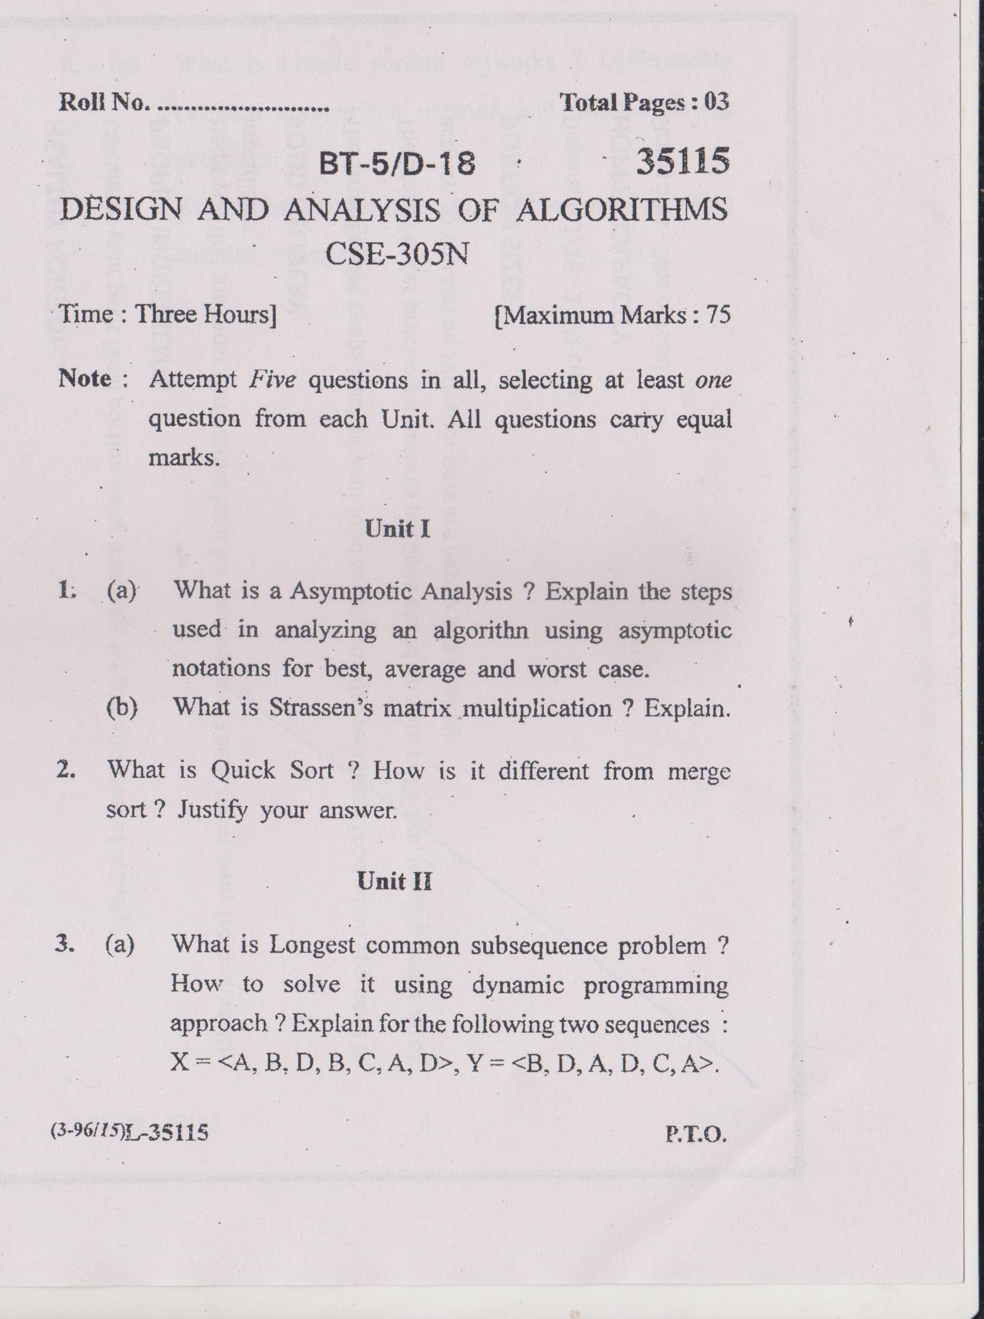

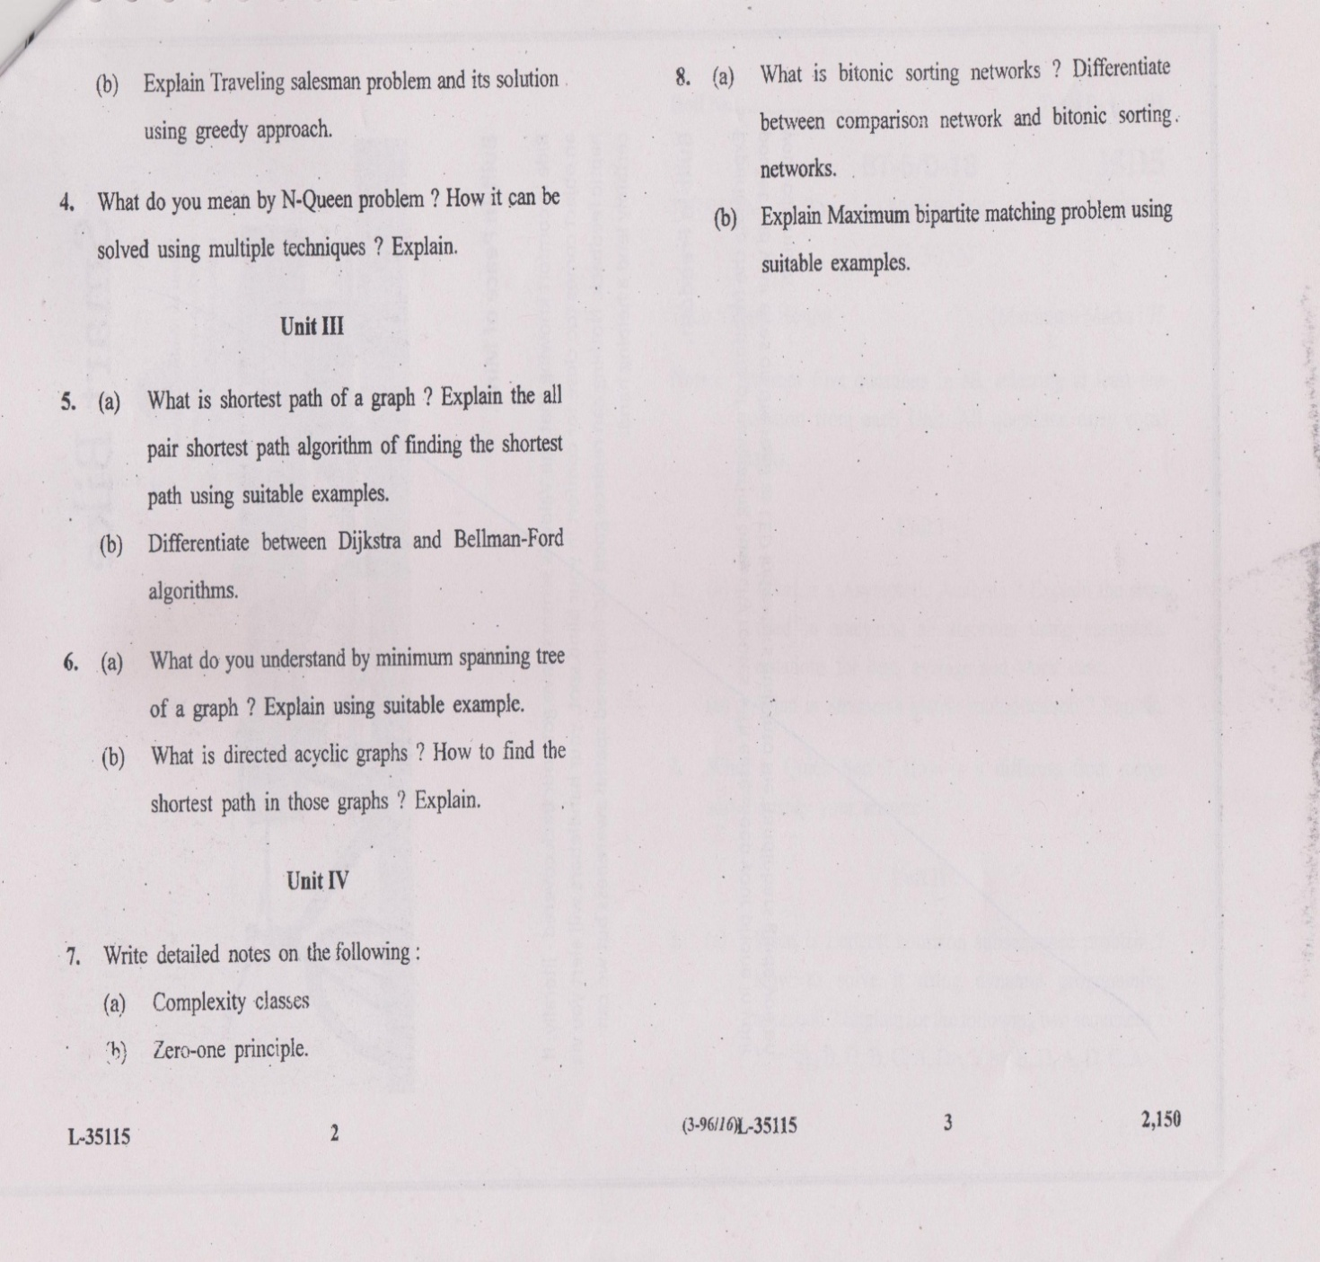

**JMIETI, Radaur**

Lesson Planning of Organisational Behaviour, Deptt. Applied Sc. & Humanities,

4th Semester

Name of Teacher : Ms. Ritika Garg

Designation : Assistant Prof.

Subject code : HM-921A

Objective of Course

1. Students will be able to understand about organizational behaviour as a discipline and understanding the concept of individual behaviour.

2. Students will be able to understand the concept and importance of personality, emotions and its importance in decision making and effective leadership.

|  |  |  |  |
| --- | --- | --- | --- |
| **Week & Month** | **Topic / Chapter Covered** | **Academic Activity** | **Test/Assignment** |
| Day 1 | Concept and importance of organizational behaviour | Lecture |  |
| Day 2 | Role of manager in OB | Lecture |  |
| Day 3 | Foundations to OB | Lecture |  |
| Day4 | Challenges and Opportunities for OB | Lecture |  |
| Day 5 | Biographical Characteristics of Learning | Lecture |  |
| Day 6 | Concept of abilities and learning | Lecture |  |
| Day 7 | Components of learning | Lecture |  |
| Day 8 | Learning and Learning Cycle | Lecture |  |
| Day 9 | Concept of Values and attitude | Lecture | Assignment |
| Day 10 | types of attitude | Lecture |  |
| Day 11 | Attitude and workforce diversity | Lecture |  |
| Day 12 | Definition and meaning of personality | Lecture |  |
| Day 13 | determinants of personality | Lecture |  |
| Day 14 | Personality traits influencing OB | Lecture |  |
| Day 15 | Nature and meaning of Emotions | Lecture |  |
| Day 16 | Emotions Dimensions | Lecture |  |
| Day 17 | Concept of Emotional Intelligence | Lecture |  |
| Day 18 | Meaning of perception | Lecture |  |
| Day 19 | factors influencing perception | Lecture |  |
| Day 20 | Rational decision making process | Lecture |  |
| Day 21 | concept of bounded rationality | Lecture |  |
| Day 22 | Leadership - Approaches - Trait, Behavioral, Situational, Emerging | Lecture |  |
| Day 23 | Concept and theories of motivation - maslow, two factor, theory XY, ERG theory, McClellands, goal setting | Lecture |  |
| Day 24 | Application of theories in organizational scenario | Lecture | Assignment |
| Day 25 | Linkage between MBO and goal setting theory | Lecture |  |
| Day 26 | Employee recognition and involvement program. | Lecture |  |
| Day 27 | Defining and Classifying of groups | Lecture |  |
| Day 28 | Stages of group development | Lecture |  |
| Day 29 | Informal and Formal Groups - Group dynamics | Lecture |  |
| Day 30 | Managing conflict and negotiation | Lecture |  |
| Day 31 | A contemporary perspective of intergroup conflict | Lecture |  |
| Day 32 | Causes of group conflicts | Lecture |  |
| Day 33 | managing intergroup conflict through resolution | Lecture |  |
| Day 34 | Meaning and importance of communication process | Lecture |  |
| Day 35 | importance of organizational communication | Lecture |  |
| Day 36 | Effective communication | Lecture |  |
| Day 37 | Organizational Stress - Definition and Meaning | Lecture |  |
| Day 38 | Sources and types of stress | Lecture |  |
| Day 39 | impact of stress on organizations | Lecture |  |
| Day 40 | Stress management techniques | Lecture |  |
| Day 41 | Meaning and nature of organizational culture | Lecture |  |
| Day 42 | Types of culture | Lecture |  |
| Day 43 | Managing cultural diversity | Lecture | Assignment |
| Day 44 | Managing change and innovation | Lecture |  |
| Day 45 | Change at work | Lecture |  |
| Day 46 | Resistance to change | Lecture |  |
| Day 47 | Revision | Lecture |  |
| Day 48 | Revision | Lecture |  |
| Day 49 | PUT | Lecture |  |

Outcome of Course

1. Students can be able to know the importance of effective motivation and its contribution in group dynamics and resolving conflicts.

2. Students will be able to understand how to overcome organizational stress by maintaining proper organizational culture and effective communication.

**Tutorial Sheet 1**

1. What is the concept and importance of Organisational Behaviour.
2. Explain the approaches to OB.
3. How does the biological characteristics effect our abilities and learning.
4. What is attitude and explain the types of attitude.

**Tutorial Sheet 2**

1. Explain Personality and how personality traits influence our behaviour in organisation.
2. What is the concept of Emotional Intelligence.
3. Define Rational decision making process.
4. Explain all the types of Leadership approaches.

**Tutorial Sheet 3**

1. Explain the concept and theories of Motivation.
2. How motivation increase employee recognition and involvement program.
3. Explain the difference between formal and informal groups.
4. What are the ways to manage conflicts and negotiation in Organisation.

**Tutorial Sheet 4**

1. Define Communication and explain its process.
2. What could be the impact of stress on organisation and how could we overcome it.
3. Explain the meaning and nature of organization culture.
4. How does the organization change help it to grow.