 JMIETI, RADAUR

Lesson Plan of Mobile Application Development, Department-CSE, Semester8th,w.e.f January

Name of Teacher : Vishal Garg

Designation : Assistant Professor

Subject with code : Mobile Application Development (CSE-404)

|  |  |  |  |  |
| --- | --- | --- | --- | --- |
| **Month** | **Class** | **Topic/Chapter Covered** | **Academic**  **Activity** | **Test/**  **Assignment** |
| JAN L1 | B.Tech 8thsem | Mobility landscape, | Lecture | Assignment from 1st Unit Tutorial sheet1 (based on previous question papers and important topics) |
| L2 | B.Tech 8thsem | Mobile platforms | Lecture |
| L3 | B.Tech 8thsem | Mobile apps, | Lecture |
| L4 | B.Tech 8thsem | Mobile apps Development | Lecture |
| L5 | B.Tech 8thsem | Overview of android platform | Lecture |
| L6 | B.Tech 8thsem | Setting up the Mobile app development | Lecture |
| L7 | B.Tech 8thsem | environment along with an Emulator | Lecture |
| L8 | B.Tech 8thsem | Activity –States and life Cycle | Lecture |
| L9 | B.Tech 8thsem | L8 Continue... | Lecture |
| L10 | B.Tech 8thsem | Interaction among the activities. | Lecture |
| FEBL11 | B.Tech 8thsem | L10 Continue... | Lecture | Assignment from 2nd Unit Tutorial sheet1 (based on previous question papers and important topics) |
| L12 | B.Tech 8thsem | App functionality beyond user interface | Lecture |
| L13 | B.Tech 8thsem | Revision | Lecture |
| L14 | B.Tech 8thsem | Threads, Async task, | Lecture |
| L 15 | B.Tech 8thsem | Task Services | Lecture |
| L 16 | B.Tech 8thsem | States and life cycle | Lecture |
| L17 | B.Tech 8thsem | Different States and life cycle | Lecture |
| MARCH  L 18 | B.Tech 8thsem | Notifications, broadcast receivers | Lecture | Assignment from 3rd Unit Tutorial sheet1 (based on previous question papers and important topics) |
| L 19 | B.Tech 8thsem | broadcast receivers | Lecture |
| L 20 | B.Tech 8thsem | Content provider | Lecture |
| L 21 | B.Tech 8thsem | Continue... | Lecture |
| L 22 | B.Tech 8thsem | Graphics and animation Custom views | Lecture |
| L23 | B.Tech 8thsem | Custom views | Lecture |
| L24 | B.Tech 8thsem | Canvas, animation APIs | Lecture |
| L25 | B.Tech 8thsem | APIs | Lecture |
| L 26 | B.Tech 8thsem | Multimedia Audio/Video playback and  Record | Lecture | Assignment from 4th Unit  Tutorial sheet1 (based on previous question papers and important topics) |
| L 27 | B.Tech 8thsem | Revision | Lecture |
| L 28 | B.Tech 8thsem | Location awareness | Lecture |
| L29 | B.Tech 8thsem | Native data handling file I/O | Lecture |
| L30 | B.Tech 8thsem | L29 Continue... | Lecture |
| L31 | B.Tech 8thsem | Different Native data handling file I/O | Lecture |
| L32 | B.Tech 8thsem | Shared preferences | Lecture |
| L33 | B.Tech 8thsem | Shared preferences in detail | Lecture |
| L34 | B.Tech 8thsem | Mobile databases such as SQLite | Lecture |
| APRIL |  | | |
| L35 | B.Tech 8thsem | Enterprise data access ( via internet  /intranet ) | Lecture |
| L36 | B.Tech 8thsem | EDA | Lecture |
| L37 | B.Tech 8thsem | Debugging mobile apps | Lecture |
| L38 | B.Tech 8thsem | Detailed Debugging mobile apps | Lecture |
| L39 | B.Tech 8thsem | White box testing | Lecture | 3rd Sessional |
| L40 | B.Tech 8thsem | Black box testing | Lecture |
| L41 | B.Tech 8thsem | Test automation of mobile app | Lecture |
| L42 | B.Tech 8thsem | JUnit for Android | Lecture |

**Course Outcomes (CO)**

1. Be exposed to technology and Mobile apps development aspects.
2. Be competent with the characterization and architecture of mobile applications.
3. Appreciation of nuances such as native hardware play, location awareness, graphics, and multimedia.
4. Perform testing, signing, packaging and distribution of mobile apps.

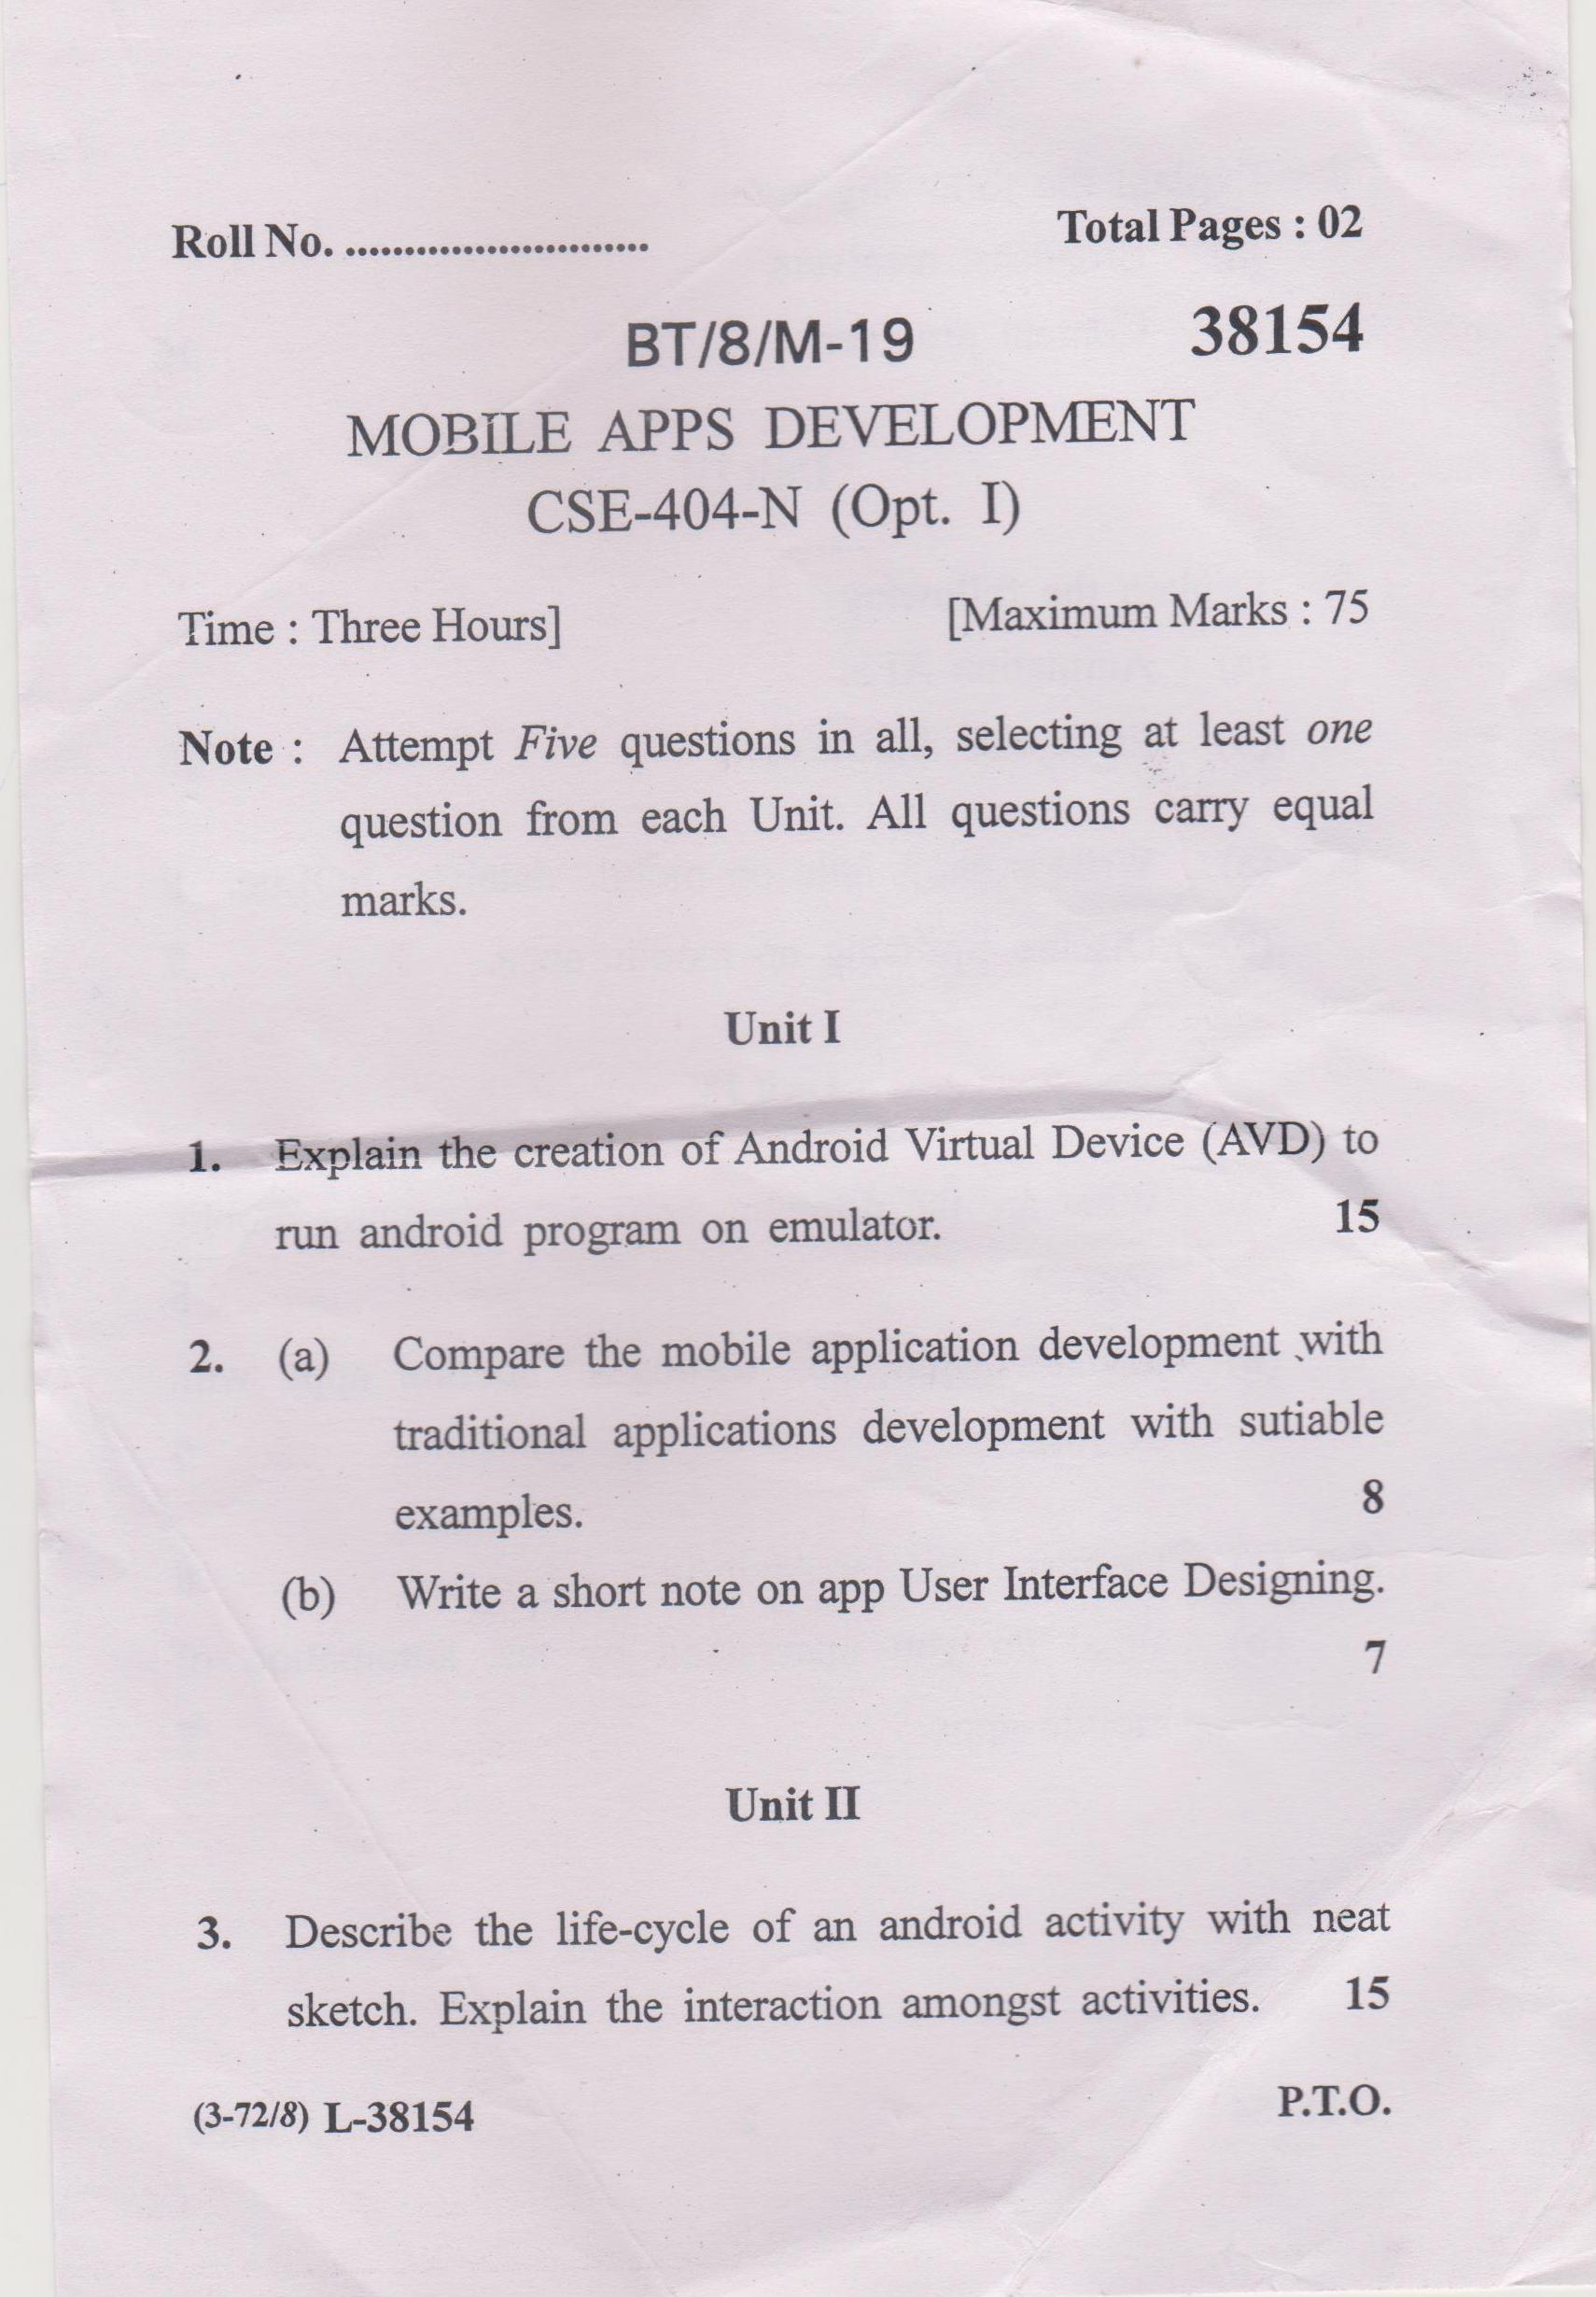

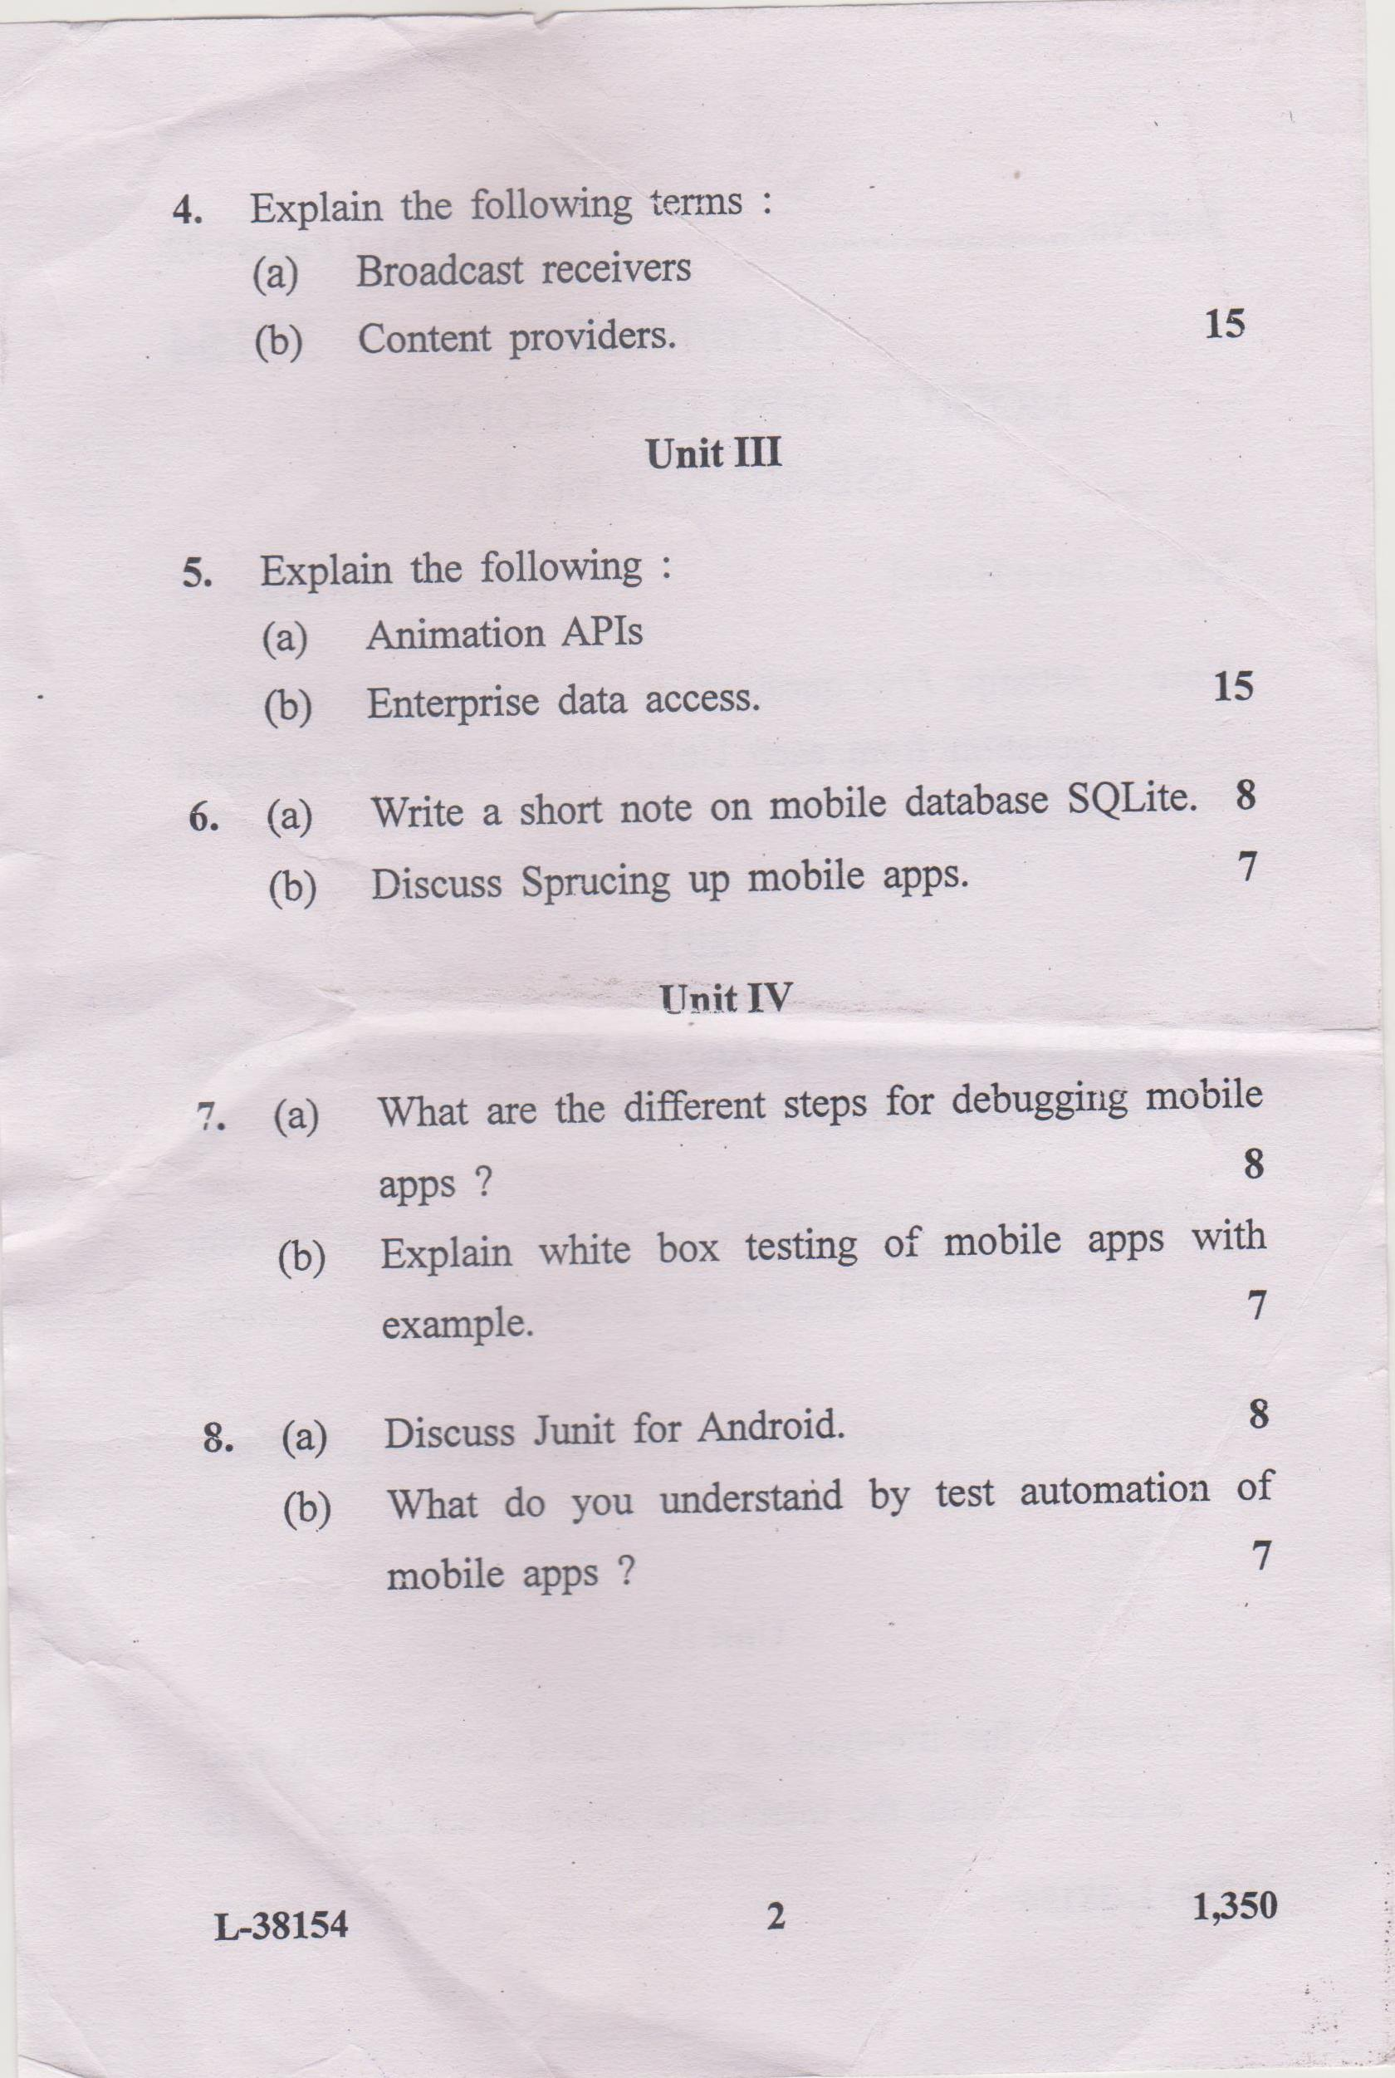



**JMIETI, Radaur**

**Lesson Plan of** Software Testing DepttCSE **Semester** 8th Semester

Name of Teacher : Tajinder Kumar

Designation : Assistant Professor

Subject with code : Software Testing

**Objective of Course:**

**To provide an understanding of concepts and techniques for testing software and assuring its quality.**

|  |  |  |  |
| --- | --- | --- | --- |
| **Week & Month** | **Topic / Chapter Covered** | **Academic Activity** | **Test/Assignment** |
| JANUARY L1 | Overview of software evolution | **LECTURE** |  |
| L2 | SDLC, Testing Process | **LECTURE** |  |
| L3 | Terminologies in Testing: Error, Fault, Failure, Verification, Validation | **LECTURE** |  |
| L4 | Difference between Verification and Validation | **LECTURE** |  |
| L5 | What is software testing and why it is so hard? | **LECTURE** |  |
| L6 | Test Cases, Test Oracles, Testing Process | **LECTURE** | **Assignment 1** |
| L7 | Limitations of Testing | **LECTURE** |  |
| L8 | Functional Testing | **LECTURE** |  |
| L9 | Boundary Value Analysis | **LECTURE** |  |
| L10 | Equivalence Class Testing | **LECTURE** |  |
| L11 | Decision Table Based Testing | **LECTURE** |  |
| FEBRUARY  L12 | Cause Effect Graphing Technique | **LECTURE** |  |
| L13 | Structural Testing | **LECTURE** |  |
| L14 | Path testing | **LECTURE** |  |
| L15 | DD-Paths | **LECTURE** |  |
| L 16 | Cyclomatic Complexity | **LECTURE** | **Assignment 2** |
| L 17 | Graph Metrics | **LECTURE** | **1st sessional** |
| L 18 | Data Flow Testing, Mutation testing | **LECTURE** |  |
| L 19 | Reducing the number of test cases | **LECTURE** | **Assignment 3** |
| L20 | Prioritization guidelines | **LECTURE** |  |
| L 21 | Priority category, Scheme | **LECTURE** | **Class Test 1** |
| L 22 | Risk Analysis, Regression Testing | **LECTURE** |  |
| MARCH  L 24 | Slice based testing | **LECTURE** |  |
| L 25 | Testing Activities | **LECTURE** |  |
| L26 | Unit Testing | **LECTURE** |  |
| L 27 | Levels of Testing | **LECTURE** |  |
| L 28 | Integration Testing, System Testing | **LECTURE** | **Class Test 2** |
| L29 | Debugging, DomainTesting | **LECTURE** |  |
| L30 | Object oriented Testing: Definition, Issues | **LECTURE** |  |
| L 31 | Class Testing | **LECTURE** | **2nd sessional** |
| L 32 | Object Oriented Integration and System Testing | **LECTURE** |  |
| L33 | Testing Web Applications: What is Web testing? | **LECTURE** |  |
| L34 | User interface Testing | **LECTURE** |  |
| L35 | Usability Testing, Security Testing | **LECTURE** | **Assignment 4** |
| L36 | **procedure of manual testing** | **LECTURE** |  |
| April L37 | **difference between a Standalone application, Client-Server application and Web application** | **LECTURE** |  |
| L38 | ****Compatibility Testing,**** Usability ****Testing,Security Testing and Soak Testing.**** | **LECTURE** |  |
| L39 | **Globalization Testing,Localization Testing,Installation Testing,** | **LECTURE** | **3rd Sessional** |
| L40 | **Exploratory Testing,Monkey Testing** | **LECTURE** |  |
| L41 | **Formal Testing,Risk Based Testing** | **LECTURE** |  |

**Outcome of Course:**

1) **Expose the criteria and parameters for the generation of test cases**.

2) **Learn the design of test cases and generating test cases**

3) **Be familiar with test management and software testing activities**

4) **Be exposed to the significance of software testing in web and Object orient techniques.**

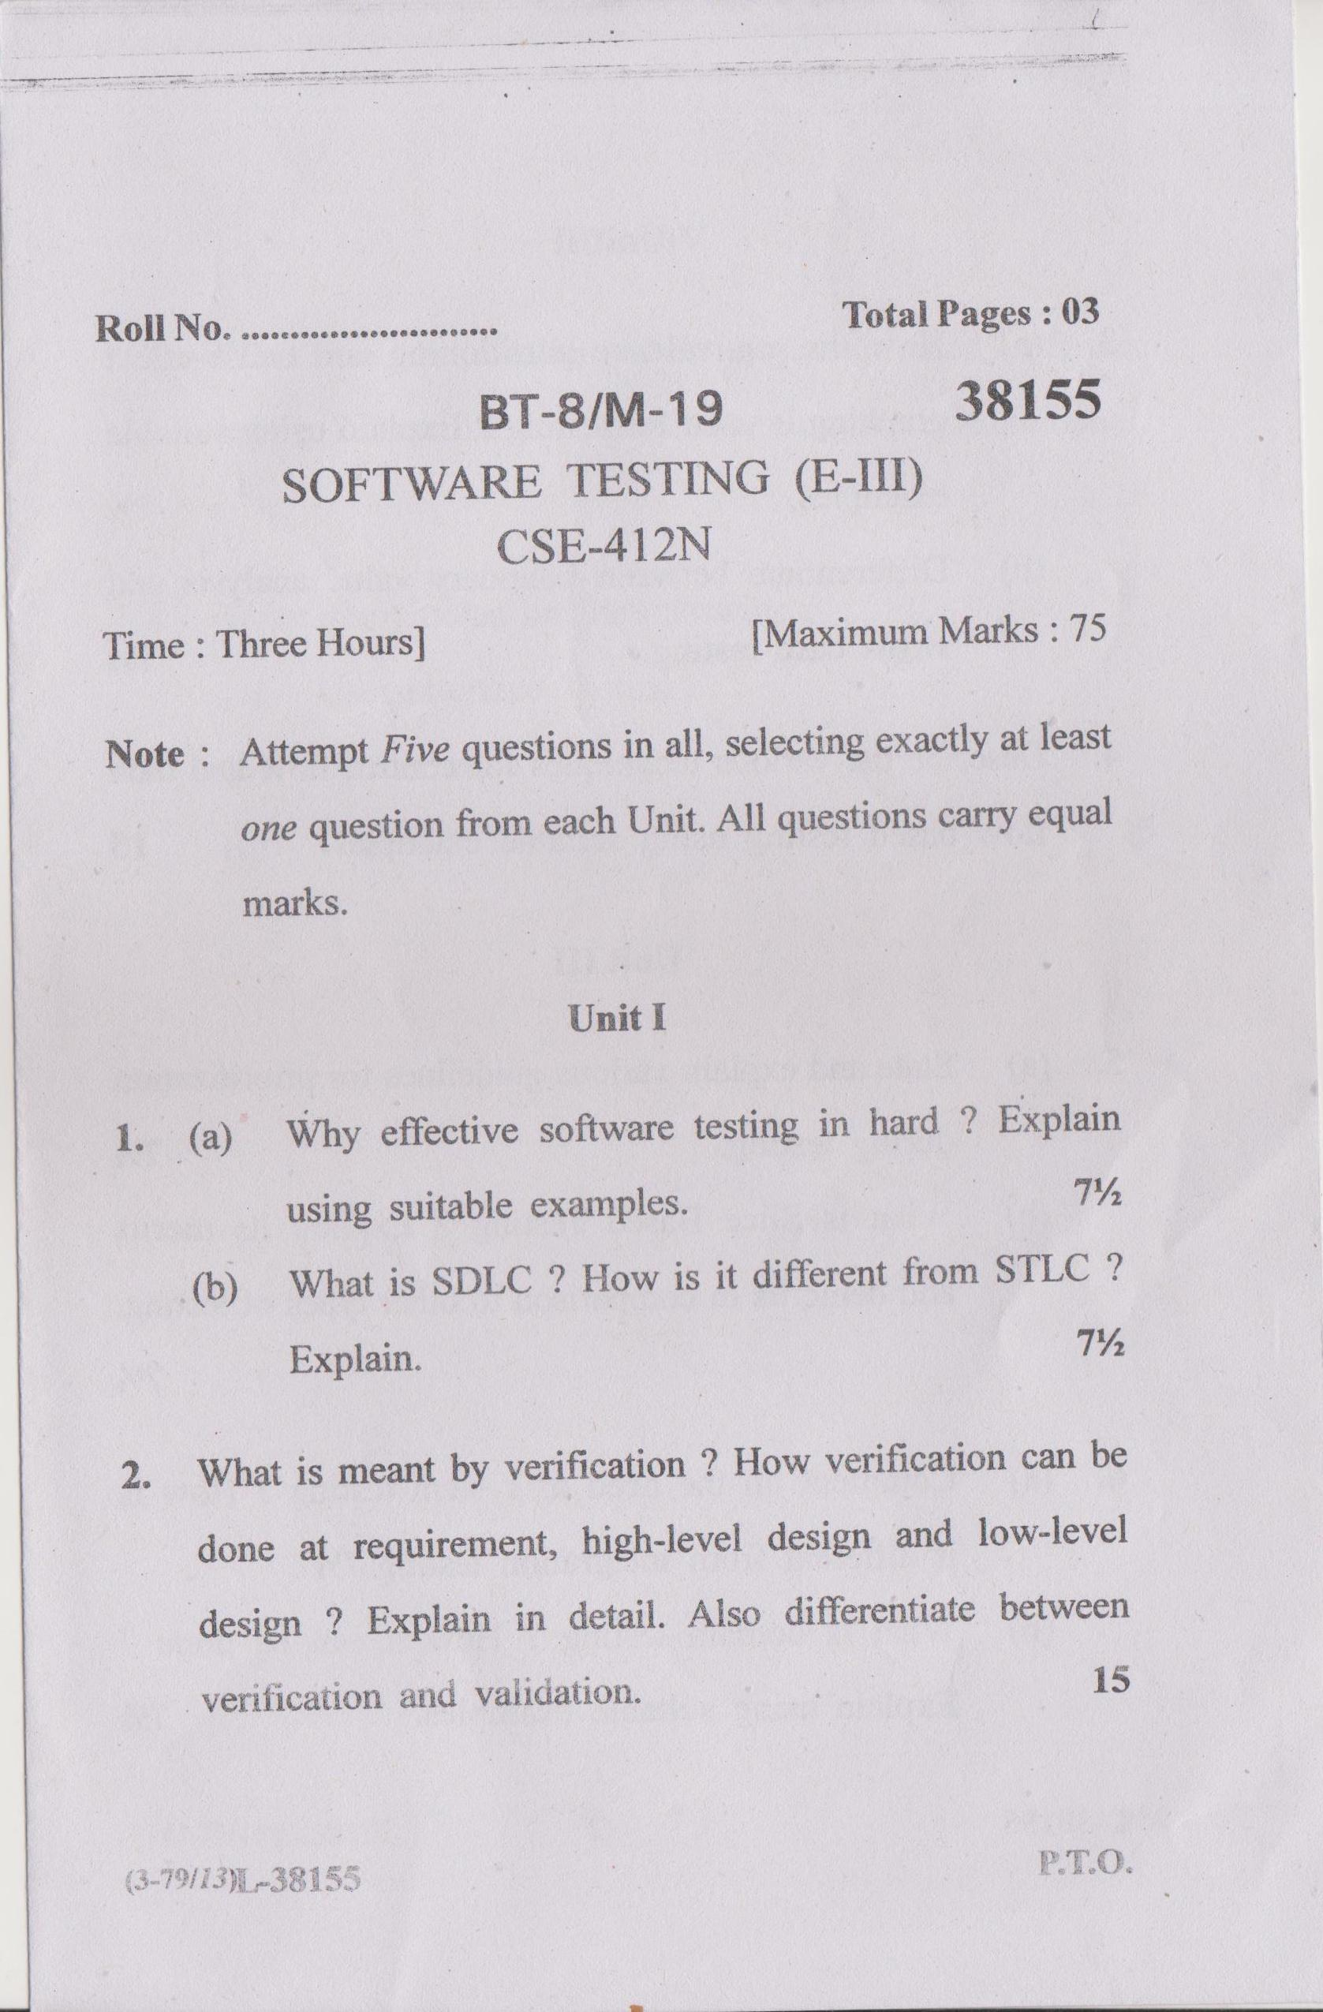

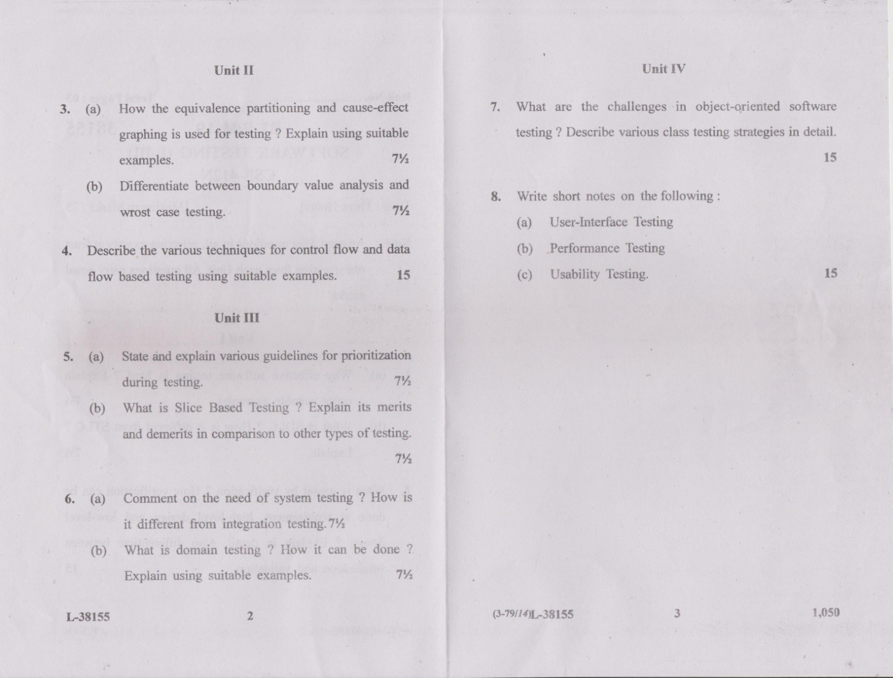



**JMIETI,RADAUR**

Lesson Planning of Neural Network Deptt CSE 8th Semester w.e.f 06/01/2020

Name of Teacher : RohitBathla

Designation : Assistant Professor

Subject with code : Neural Network

Objective:

|  |  |  |  |  |
| --- | --- | --- | --- | --- |
| **Month** | **Class** | **Topic/Chapter Covered** | **Academic**  **Activity** | **Test/**  **Assignment** |
| JANUARY  L1 | B.Tech 8thsem | Introduction : Concepts of neural networks | Lecture | Assignment from 1st Unit Tute sheet1 (based on previous question papers and important topics) |
| L2 | B.Tech 8thsem | Basics of neural networks | Lecture |
| L3 | B.Tech 8thsem | Characteristics of neural networks | Lecture |
| L4 | B.Tech 8thsem | L3 Continue...... | Lecture |
| L5 | B.Tech 8thsem | Applications of neural networks | Lecture |
| L6 | B.Tech 8thsem | L5 Continue.... | Lecture |
| L7 | B.Tech 8thsem | Fundamentals of neural networks | Lecture |
| L8 | B.Tech 8thsem | Details of Fundamentals of neural networks | Lecture |
| L9 | B.Tech 8thsem | What do you mean by Prototype | Lecture |
| L10 | B.Tech 8thsem | The biological prototype | Lecture |
| L11 | B.Tech 8thsem | Neuron concept , | Lecture |
| FEBRUARY  L12 | B.Tech 8thsem | single layer neural networks | Lecture | Assignment from 2nd Unit Tute sheet1 (based on previous question papers and important topics) |
| L13 | B.Tech 8thsem | Multi-Layer neural networks. | Lecture |
| L14 | B.Tech 8thsem | Terminology | Lecture |
| L15 | B.Tech 8thsem | Notation of neural networks | Lecture |
| L 16 | B.Tech 8thsem | representation of neural networks | Lecture |
| L 17 | B.Tech 8thsem | Training of artificial neural networks | Lecture |
| L 18 | B.Tech 8thsem | L17 Continue.... | Lecture |
| L 19 | B.Tech 8thsem | Representations of perceptron, | Lecture |
| L20 | B.Tech 8thsem | L20 Continue.... | Lecture |
| L 21 | B.Tech 8thsem | perceptron learning and training | Lecture |  |
| L 22 | B.Tech 8thsem | Perceptrontraining | Lecture |

|  |  |  |  |  |
| --- | --- | --- | --- | --- |
| MMARCH  L 24 | B.Tech 8thsem | Classification , linear separability | Lecture | Assignment from 3rd Unit Tute sheet1 (based on previous question papers and important topics) |
| L 25 | B.Tech 8thsem | linear separability | Lecture |
| L26 | B.Tech 8thsem | Hopfield nets: Structure, | Lecture |
| L 27 | B.Tech 8thsem | Structure, | Lecture |
| L 28 | B.Tech 8thsem | Training | Lecture |
| L29 | B.Tech 8thsem | applications, | Lecture |
| L30 | B.Tech 8thsem | Back propagation : concept, applications | Lecture |
| L 31 | B.Tech 8thsem | Back propagation Training algorithms. | Lecture |
| L 32 | B.Tech 8thsem | Counter propagation Networks: kohonan  Network | Lecture |
| L33 | B.Tech 8thsem | gross berg layer &Training | Lecture |
| L34 | B.Tech 8thsem | Applications of counter propagation. | Lecture |
| L35 | B.Tech 8thsem | Image classification. | Lecture |
| L 36 | B.Tech 8thsem | Bi-directional associative memories | Lecture | Assignment from 4th Unit  Tute sheet1 (based on previous question papers and important topics) |
| L 37 | B.Tech 8thsem | L34 Continue... | Lecture |
| L 38 | B.Tech 8thsem | Structure, retrieving a stored association, | Lecture |
| L 39 | B.Tech 8thsem | encoding associations | Lecture |
| L40 | B.Tech 8thsem | Art architecture | Lecture |
| L41 | B.Tech 8thsem | Art Classification operation, | Lecture |
| L42 | B.Tech 8thsem | ART implementation | Lecture |
| L43 | B.Tech 8thsem | characteristics of ART | Lecture |
| L44 | B.Tech 8thsem | Image compression using art , | Lecture |
| APRIL  L45 | B.Tech 8thsem | optical neural networks , | Lecture |
| L46 | B.Tech 8thsem | Vector Matrix multipliers | Lecture |
| L 47 | B.Tech 8thsem | Hop field net using Electro optical matrix  multipliers, | Lecture |
| L 48 | B.Tech 8thsem | holographic correlator, | Lecture |
| L 49 | B.Tech 8thsem | Optical Hopfield net suing volume holograms, | Lecture |
| L 50 | B.Tech 8thsem | cognitrons and neocognitrons: Structure | Lecture |

|  |  |  |  |  |
| --- | --- | --- | --- | --- |
|  |  | and training |  |  |
| L 51 | B.Tech 8thsem | Fuzzy Logic :introduction of fuzzy logic,  Classical and fuzzy sets | Lecture |
| L52 | B.Tech 8thsem | Overview of classical sets, membership  Function, Fuzzy rule generation, | Lecture |
| L53 | B.Tech 8thsem | Operations on Fuzzy sets: compliment , | Lecture |
| L54 | B.Tech 8thsem | intersections, Unions, combinations of operations, | Lecture |
| L55 | B.Tech 8thsem | Aggregation Operations, Fuzzy Arithmetic: Fuzzy Numbers, Linguistic variables, | Lecture |
| L56 | B.Tech 8thsem | Arithmetic Operations on Intervals & Numbers, | Lecture |
| L57 | B.Tech 8thsem | Lattice of Fuzzy Numbers, Fuzzy Equations | Lecture |
| L58 | B.Tech 8thsem | Introduction of Neruo Fuzzy systems architecture of Neuro Fuzzy networks | Lecture |
| L59 | B.Tech 8thsem | Genetic Algorithms: genetic algorithm  implementation in problem solving and | Lecture |
| L60 | B.Tech 8thsem | Working of genetic algorithms evolving  neural networks | Lecture |

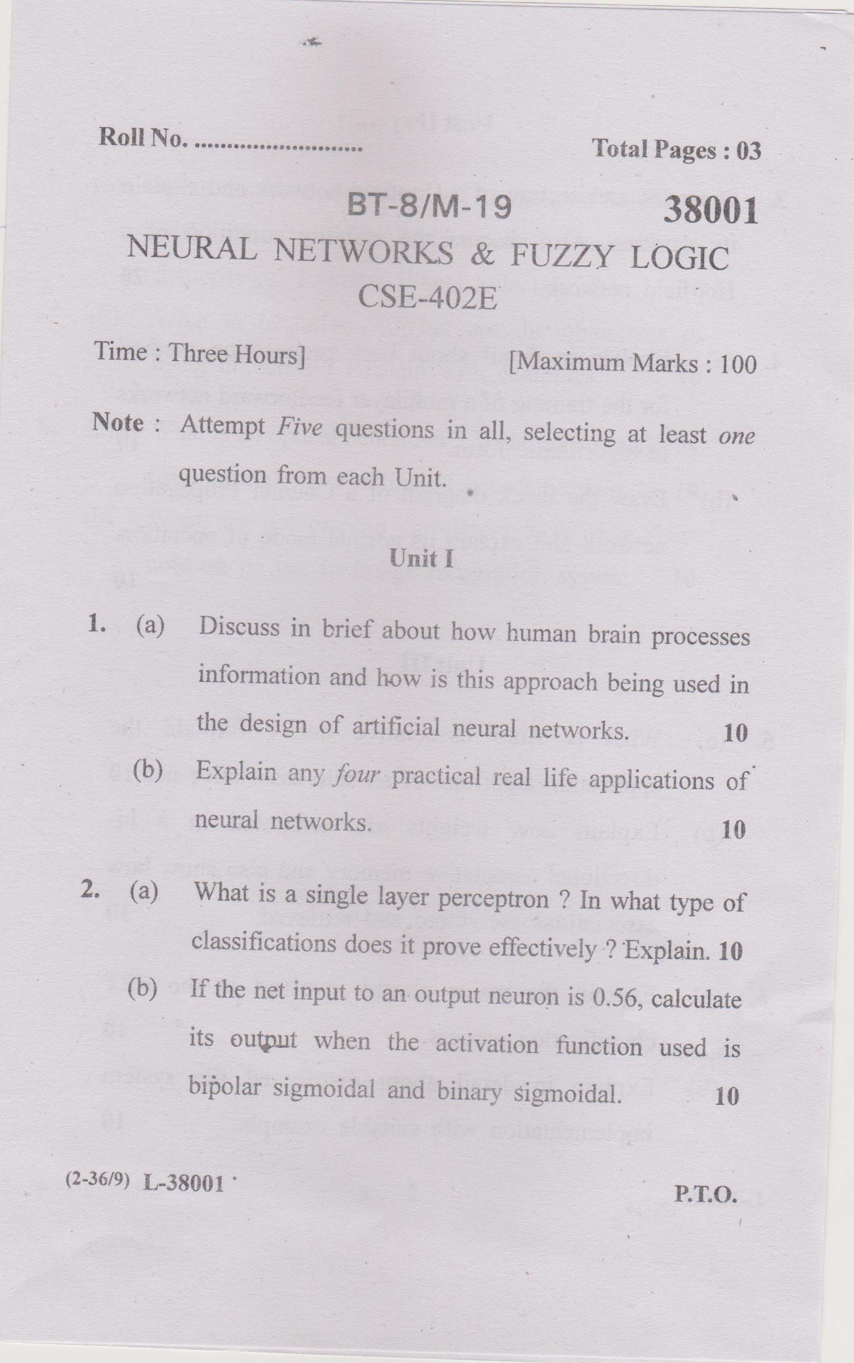

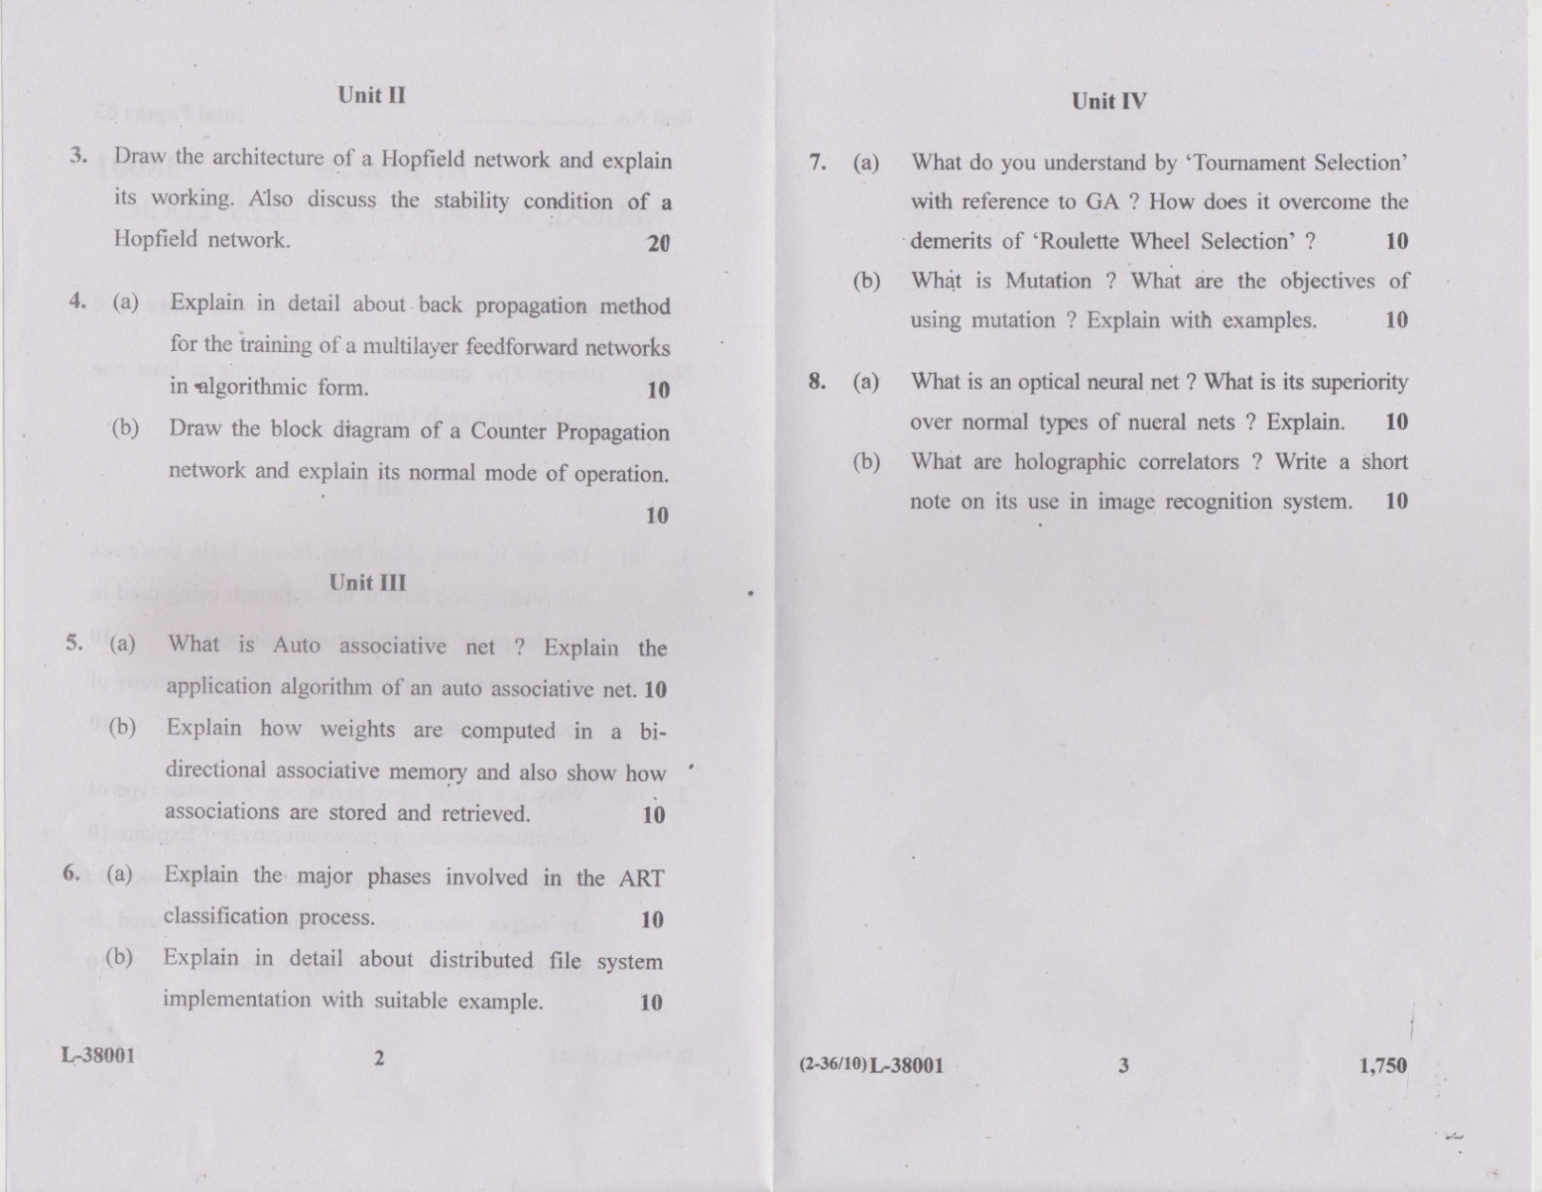



**JMIETI, Radaur**

Lesson Planning of Parallel Computing Deptt. CSE Semester 8th

Name of Teacher : Ms.Ruchi Gupta

Designation : Assistant Professor

Subject with code : Parallel Computing (CSE-418)

Objectives of Course :

1. Parallel Programming Platforms.

2. Principles of Parallel Algorithm Design.

3. Analytical Modeling of Parallel Programs.

4. Parallel Programming Paradigms.

|  |  |  |  |
| --- | --- | --- | --- |
| Month | Topic /chapter  covered | Academic activity | Test / assignment |
| JAN | Introduction: The state of computing, system attributes to performance | Teaching |  |
| JAN | Paradigms of parallel computing: Synchronous – Vector/ Array, SIMD, systolic | Teaching |  |
| JAN | Asynchronous- MIMD, reduction paradigm. | Teaching |  |
| JAN | Hardware Taxonomy: Flynn’s classification | Teaching |  |
| JAN | Feng’s classification, handler’s classification | Teaching |  |
| JAN | Software taxonomy: Kung’s taxonomy | Teaching |  |
| JAN |  |  | Test |
| FEB | Abstract parallel computational models: combinational circuits, sorting network | Teaching |  |
| FEB | PRAM models, VLSI complexity model, Interconnections RAMs | Teaching |  |
| FEB | Parallelism approaches- data parallelism, control parallelism, | Teaching |  |
| FEB | Conditions of parallelism: Data, control and resource dependencies | Teaching |  |
| FEB | Hardware and software parallelism. | Teaching |  |
| FEB | Performance metrics: Laws governing performance measurements | Teaching |  |
| FEB | Metrics- speedups, efficiency, utilization, communication overheads, single/ multiple program performances. | Teaching |  |
| FEB |  |  | Test |
| MAR | Parallel processors: taxonomy and topology: shared memory multi processors | Teaching |  |
| MAR | Distributed memory multicomputer, static and dynamic interconnections. | Teaching |  |
| MAR | Parallel programming: shared memory programming, distributed memory programming | Teaching |  |
| MAR | Object oriented programming, | Teaching |  |
| MAR | Data parallel programming | Teaching |  |
| MAR | Distributed memory programming | Teaching |  |
| MAR | Functional programming | Teaching |  |
| MAR | Data flow programming | Teaching |  |
| MAR |  |  | Test |
| APR | Scheduling and parallelization: Loop parallelization and pipelining | Teaching |  |
| APR | Loop transformation theory,parallelization and wave fronting, | Teaching |  |
| APR | Tiling and localization, | Teaching |  |
| APR | Software pipelining, | Teaching |  |
| APR | Scheduling parallel programs, program partitioning and scheduling: | Teaching |  |
| APR | Grain size, latency, grain packing and scheduling | Teaching |  |
| APR | Loop scheduling, Parallelization of sequential programs | Teaching |  |
| APR |  |  | Test |

Outcomes of Course:

1. Classify various synchronous and asynchronous paradigms of parallel computing as well as identify some of the taxonomies for architectural classification of parallel computers.
2. Compare various parallel computation models and approaches and describe different performance metrics in parallel computers.
3. Distinguish shared memory and distributed memory multiprocessors and explainvarious parallel programming models and relative advantages and disadvantages of interconnection networks based on network parameters for reliable connections and achieving efficient speed.
4. Examine various techniques of parallelizing loops and sequential programs and scheduling.

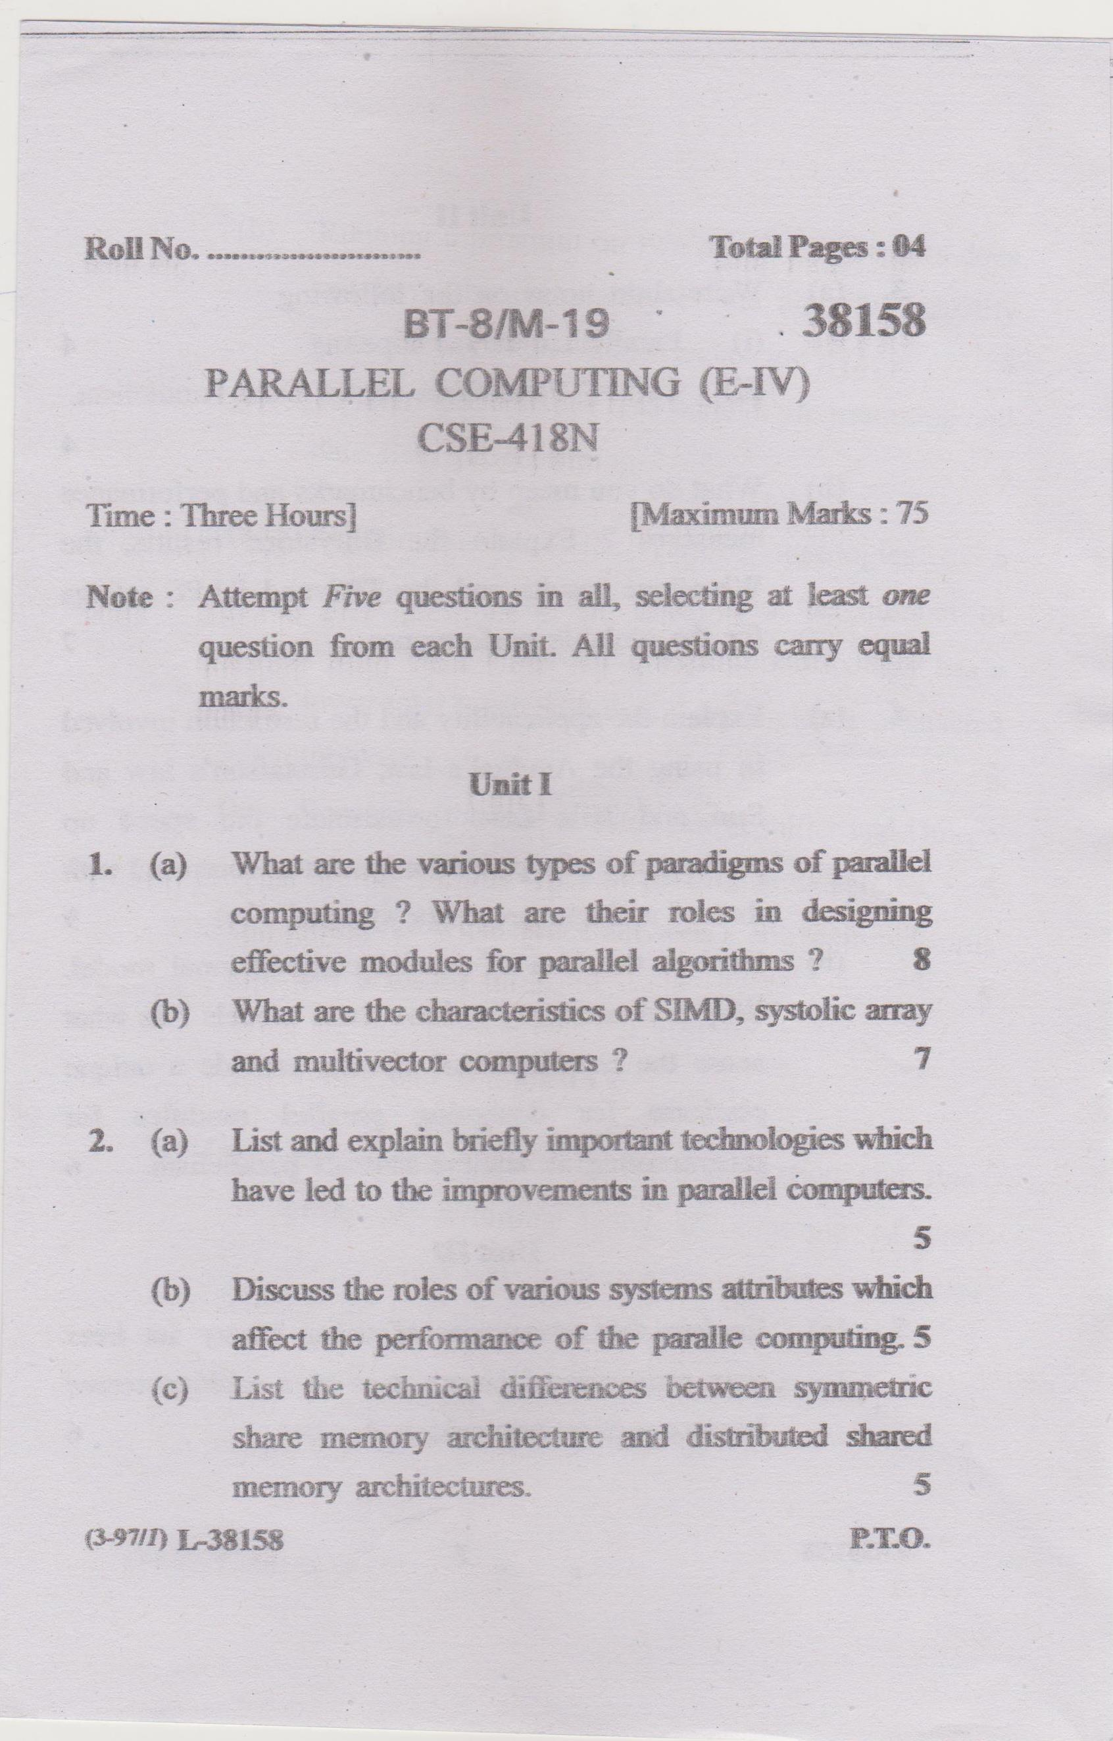

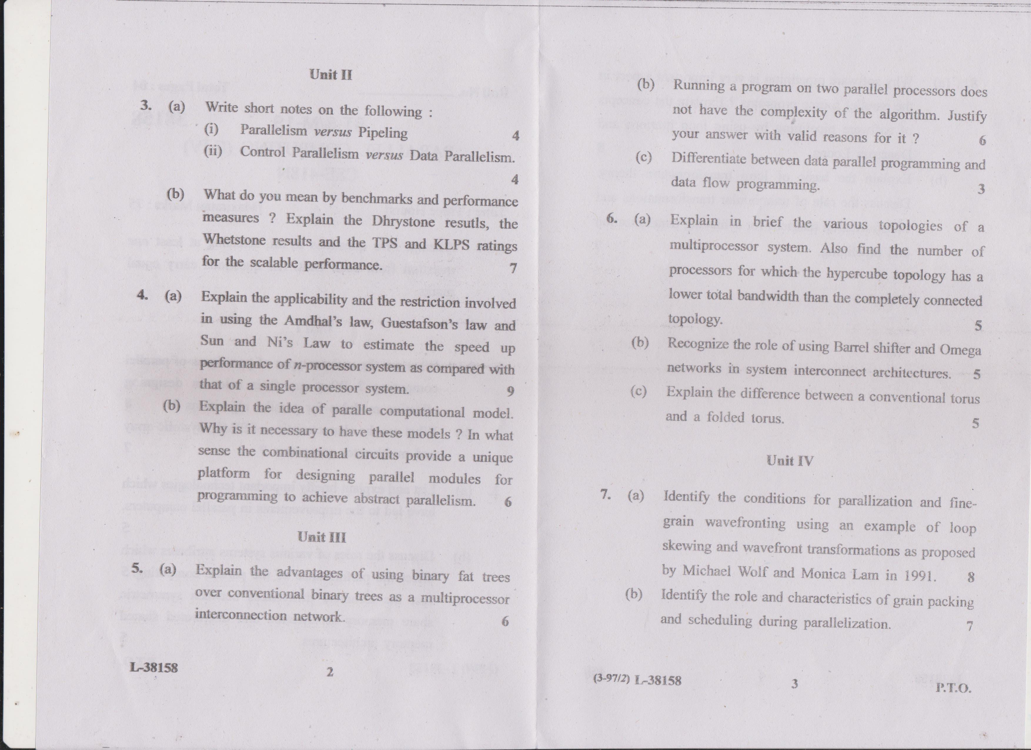

(Sign. of HOD) (Sign. of Teacher Concerned with date)